

Worcester Polytechnic Institute

Biomedical Engineering Design (BME3300)

March 3, 2023

Avinash Bissoondial

James Doucette

Gray Hauff

Tera Keang

# Abstract

In the 1980s, the American Academy of Pediatrics (AAP) noticed that sudden infant death syndrome (SIDS) was due to the infant lying prone on their stomachs. Therefore, they suggested that the infant should lay prone on their backs to prevent SIDS, but this caused the increase in flat head syndrome. Flat head syndrome (FHS), known as positional plagiocephaly, occurs in 50% of infants, where the development of the medical condition is sometimes irreversible. Since infants’ cranial structures are softest and in the greatest development during their first four months of their life, FHS is most commonly formed within one year old. Physicians have suggested that FHS can be treated naturally through “tummy time”; time dedicated for the infant to remain on their stomachs while they are awake to allow for their heads to reform their skull shapes. However, there are less natural treatments for FHS: a pillow with a head-indent, the Perfect Noggin, and a cranial helmet. Although these pillows are relatively cheap and accessible, they are not FDA approved as they have a high possibility in SIDS. The Perfect Noggin is a medical device that incorporates the indented pillow, but still has the possibility of FHS to occur. Lastly, the cranial helmet is the most common treatment of FHS, where it may come with psychosocial effects that would alter the development of the child in the long term. Thus, the goal of this project is to prevent the development of the positional plagiocephaly, rather than treating it after it is developed. We have designed the Teeter-Tot device that contains two inflatable pads that alternate with inflating to encourage the turning of the infant’s head. After the final product was assembled, the following tests were conducted to determine the feasibility and success of each component: cycle duration, size compatibility, portability, sound, rotation angle, use assembly, location versatility, power duration, and a glue test. Out of the nine tests conducted, six tests passed. Evaluating the Teeter-Tot, the concept of the device is unique which makes it directly incomparable to the current products on the market that have a similar goal. Ethical issues will arise when clinical testing is to be conducted, as it is difficult to truly obtain consent of the infants when testing. Additionally, the reliance on the device may result in caretaker negligence. Upon reflection of the final device’s features, the device could exponentially improve with access to higher quality resources, and may help pass the tests that failed. Ultimately the device’s concept can be extended beyond the application on infants, where the concept can be a full-body size for preventing bed sores for individuals in a coma.

# 

# 

# 

# Authorship

| **Section** | **Primary Author(s)** |
| --- | --- |
| Abstract | TK |
| 1.0 Introduction | AB |
| 2.0 Literature Review | TK |
| 2.1 Skull Development | TK |
| 2.2 Cranial Deformities | TK |
| 2.2.1 Craniosynostosis | TK |
| 2.2.2 Positional Plagiocephaly | TK |
| 2.3 Demographic Affected | JD, TK |
| 2.4 Current Solutions | AB, GH |
| 3.0 Project Strategy | TK |
| 3.1 Problem Statement | TK |
| 3.2 Objectives | TK |
| 3.3 Management Approach | TK |
| 3.3.1 Gantt Chart | All |
| 3.3.2 Work Breakdown Structure | All |
| 4.0 Design Process | TK |
| 4.1 Functional Blocks | TK |
| 4.2 Technical Specifications | TK |
| 4.3 Conceptual Brainstorming | TK |
| 4.4 Preliminary Designs | TK |
| 4.4.1 Preliminary Design 1 | JD |
| 4.4.2 Preliminary Design 2 | AB |
| 4.4.3 Preliminary Design 3 | GH |
| 4.5 Design Decision | TK |
| 5.0 Final Design | TK |
| 5.1 General Overview | JD, TK |
| 5.2 Material Components | TK |
| 5.2.1 Inflatable Pillow and Tubing | JD |
| 5.2.2 Control Panel | JD |
| 5.2.3 Arduino and Accessories | AB |
| 5.2.4 Power Sources | AB |
| 5.2.5 Pumps | TK |
| 5.2.6 Device Baseboard | GH |
| 5.2.7 Cover | GH |
| 5.2.8 Strap | TK |
| 5.2.9 Handle | TK |
| 5.2.10 Glue | TK |
| 5.2.11 Testing Model: Infant Head | TK |
| 5.2.12 Cost Analysis | TK |
| 5.3 Mechanical Components | JD |
| 5.4 Electrical Components | AB |
| 5.4.1 Circuit | AB |
| 5.4.2 Arduino Code | AB |
| 6.0 Testing | All |
| 6.1 Cycle Duration | TK |
| 6.2 Size Compatibility | GH |
| 6.3 Portability | GH |
| 6.4 Sound Test | JD |
| 6.5 Rotation Angle | TK |
| 6.6 User Assembly | AB |
| 6.7 Location Versatility | JD |
| 6.8 Power Duration | AB |
| 7.0 Discussion | - |
| 7.1 Regulations and Standards | GH |
| 7.2 Ethics | TK |
| 7.2.1 Clinical Trials | TK |
| 7.2.2 Caretaker Negligence | TK |
| 8.0 Conclusion | JD |
| 8.1 Recommendations and Future Modifications | JD |
| 8.2 Additional Applications | JD |
| 9.0 References | All |
| 10.0 Appendix | AB |

# 

# Table of Contents

**Abstract 1**

**Authorship** **2**

**Table of Contents** **5**

**List of Figures** **7**

**List of Tables** **8**

**1.0 Introduction** **9**

**2.0 Literature Review** **9**

2.1 Skull Development 9

2.2 Cranial Deformities 10

2.2.1 Craniosynostosis 10

2.2.2 Positional Plagiocephaly 10

2.3 Demographic Affected 12

2.4 Current Solutions 13

**3.0 Project Strategy** **15**

3.1 Problem Statement 15

3.2 Objectives 16

3.3 Management Approach 17

3.3.1 Gantt Chart 18

3.3.2 Work Breakdown Structure 19

**4.0 Design Process 1****9**

4.1 Functional Blocks 19

4.2 Technical Specifications 20

4.3 Conceptual Brainstorming 21

4.4 Preliminary Designs 22

4.4.1 Preliminary Design 1: Inflatable Rotating Cushion 22

4.4.2 Preliminary Design 2: No-Stress Infant Car Seat 23

4.4.3 Preliminary Design 3: Mechanical Arm Mechanism 23

4.5 Design Decision 24

**5.0 Final Design 2****6**

5.1 General Overview 26

5.2 Material Components 27

5.2.1 Inflatable Pillow and Tubing 28

5.2.2 Control Panel 29

5.2.3 Arduino and Accessories 29

5.2.4 Power Sources 30

5.2.5 Pumps 31

5.2.6 Device Baseboard 31

5.2.7 Cover 32

5.2.8 Strap 33

5.2.9 Handle 33

5.2.10 Glue 34

5.2.11 Testing Model: Infant Head 37

5.2.12 Cost Analysis 40

5.3 Mechanical Components 41

5.4 Electrical Components 42

5.4.1 Circuit 42

5.4.2 Arduino Code 43

**6.0 Testing** **45**

6.1 Cycle Duration 45

6.2 Size Compatibility 46

6.3 Portability 46

6.4 Sound Test 47

6.5 Rotation Angle 47

6.6 User Assembly 50

6.7 Location Versatility 52

6.8 Power Duration 53

**7.0 Discussion** **53**

7.1 Regulations and Standards 53

7.2 Ethics 54

7.2.1 Clinical Testing 54

7.2.2 Caretaker Negligence 54

**8.0 Conclusion** **55**

8.1 Recommendations and Future Modifications55

8.2 Additional Applications 55

**9.0 References** **56**

**10.0 Appendix 63**

# 

# List of Figures

| **Figure 2.1:** Comparison of a normal cranial structure to a positional flattened cranial  structure  **Figure 2.2:** An illustration of how a cranial helmet works to reshape an infant’s head  **Figure 2.3:** The Perfect Noggin  **Figure 3.1:** Project Gantt Chart  **Figure 3.2:** Work Breakdown Structure  **Figure 4.1:** Sketch of Preliminary Design 1  **Figure 5.1:** Final Design  **Figure 5.2:** Shape of the inflatable pad  **Figure 5.3:** Dimensions of the inflatable pad  **Figure 5.4:** Arduino used in prototype with three buttons  **Figure 5.5:** Most components within the control board  **Figure 5.6:** Air pump/vacuum for final device  **Figure 5.7:** Air pump/vacuum tubing  **Figure 5.8:** The section of the polycarbonate sheet that we used for the device  **Figure 5.9:** The inflatable pads with the cover material  **Figure 5.10:** Elastic security strap  **Figure 5.11:** Handle  **Figure 5.12:** Glue options  **Figure 5.13:**  Glue-to-material test  **Figure 5.14:** Model infant heads side-view and top-view  **Figure 5.15:** Fully assembled infant head  **Figure 5.16:** CAD Model of Control Board  **Figure 5.17:** Sample diagram of circuit (MYTECTUTOR)  **Figure 5.18:** Defining a Check Buttons Function  **Figure 5.19:** Beginning of Loop that Initially Inflates and Deflates Pad  **Figure 5.20:** Code for Time in Between Each Inflation Cycle  **Figure 6.1:** Infant 1 Images Taken for Rotation Angle Analysis  **Figure 6.2:** Visualization of Angle of Rotation Calculation  **Figure 6.3:** User Assembly Test Results  **Figure 6.4:** Teeter-Tot User Assembly Guide  **Figure 6.5:** Power Duration Test Results | 12  14  15  1920  24  29  30  28  31  32  33  34  34  35  36  36  37  38  41  41  43  44  45  46  46  50  51  52  53  55 |
| --- | --- |

# 

# List of Tables

| **Table 4.1:** Functional Blocks  **Table 4.2:** Technical Specifications  **Table 4.3:** Pairwise Comparison Chart  **Table 4.4:** Pugh Concept Selection Matrix  **Table 5.1:** Glue-to-material scorings  **Table 5.2:** Infant Head Circumference Calculation  **Table 5.3:** Infant Head Model Size Calculations  **Table 5.4:** Teeter-Tot Final Cost  **Table 6.1:** Duration of Position Transition of Infant Head  **Table 6.2:** Fit of Model Infant Heads on Device  **Table 6.3:** Volume of Both Inflation and Deflation  **Table 6.4:** Normalized Coordinate Values for Rotation Angle Test  **Table 6.5:** Calculator Between Two Points  **Table 6.6:** Calculator of Angle Rotation  **Table 6.7:** Location Safety for Device | 21  21  25  26  38  37  40  42  47  48  49  50  51  52  54 |
| --- | --- |

# 

# 1.0 Introduction

Positional plagiocephaly (PP), also known as flat head syndrome (FHS) is common in 50% of infants, as stated by the American Academy of Family Physicians (27). Flat head syndrome is when an infant's head becomes flattened on the sides or back of the head due to the head excessively resting on a singular area (50). Their skulls also contain fontanels, soft spots, due to the lack of fused plates in their skull (48) that encourage the deformation of their skulls.

Currently, there are minimal solutions for flat head syndrome. Unfortunately, they are limiting or uncomfortable for infant movement. Surprisingly, the main focus for FHS is treatment rather than prevention based on the quantity of methods for fixing FHS. The cheapest and simplest device is a basic pillow with an indent in the center for where the head is to be placed. These pillows range from $10 to $40. However, the FDA does not approve of pillows for infants due to the increased risk of suffocation and sudden infant death syndrome (SIDS). The second device is the Perfect Noggin, a bassinet that has a head-component similar to the pillow, which retails for $150. The last device is one of the most commonly-known treatments: the cranial helmet, which can cost up to $3000. Although this is currently the most effective treatment for flat head syndrome, there are lots of psychosocial effects that can alter the development of the child when needing to wear this helmet. The most common suggestion to prevent FHS in infant development is to avoid resting on one side of the head for a long time (47). It is recommended that the infant should be rotated to balance sleeping on their back, right, and left sides of their body throughout the night.

The goal of this project is to develop an infant-safe device that periodically rotates an infant’s head while they are asleep without disruption to prevent the development of plagiocephaly (flat head syndrome, FHS). This device will be comfortable and adjustable for the user as well as affordable for the client. This project will be targeted towards parents, caretakers, nurses or any other person that takes care of sleeping infants.

# 

# 2.0 Literature Review

Prior to developing a medical device to prevent the development of flat head syndrome (FHS), extensive research was conducted to evaluate the source, clinical need, and current solutions pertaining to the medical condition. Peer-reviewed sources and medical journals were evaluated to gather information to aid with achieving our project goal.

## 2.1 Skull Development

The skull of a newborn infant differs greatly from the anatomy of a fully-developed adult skull. The infant contains 5 separate bones, two frontal bones, two parietal, and one occipital bone, that are separated by joints, called sutures, that facilitate and ease the process of skull development in the early stages of life. The purpose of cranial sutures for infants is to allow for the growth of the skull and brain (14), and normal cranial sutures begin to close between the first nine to eleven months.

The growth of the craniofacial skeleton is based on the concepts of displacement and bone remodeling; the infant requires rapid and symmetrical displacement of the frontal, parietal, and occipital cranial bones and bone remodeling through the osseous, bone cells, deposition amongst the cranial sutures and matrixes (16). This growth cycle includes development of the calvarium, which is the formation of the base of the skull and the face and ultimately is the main feature that allows for easy pre-diagnosis of craniofacial abnormalities. The reason for the malleability of the skull immediately after birth is to allow them to easily pass through the birth canal, so the average human skull takes nine to eighteen months to fully form (32).

## 2.2 Cranial Deformities

There are multiple causes of flat head syndrome as there are different types of FHS: plagiocephaly, brachycephaly, and dolichocephaly. These types vary due to the area where the flatness of the head occurs: plagiocephaly is flatness on the back of the head, brachycephaly is flatness on the back and both sides of the head, and dolichocephaly is flatness on only the sides of the head where the front and back of the head becomes elongated (1). Within each type of flat head syndrome, there are two different causes: congenital and positional, or deformational.

### 2.2.1 Craniosynostosis

Congenital FHS, also known as craniosynostosis, is a rare birth defect that occurs in about one in every 2,200 live births (2). The incidence occurs in the ureto due to the fusion of one or more cranial sutures, in which its true cause can be spontaneous, syndromic, or familial. Preliminary diagnosis of craniosynostosis is from viewing an abnormally-shaped skull, and further medical examinations officially diagnoses the syndrome. The abnormal development can be traced back to genetic disorders, where there may be inheritance of the autosomal dominant or autosomal recessive genes (2), which is the cause 20% of the time, or most of the time the syndrome is due to the restriction of fetal head movement while in the womb (15). Additionally, roughly 60% of craniosynostosis is nonsyndromic, or non-inherited, and 40% is syndromic, or genetic (25). The genetic causes of craniosynostosis is predisposed to early suture fusion whereas the etiological cause is due to the physical barrier of fetal skull movement during pregnancy.

Unfortunately, the diagnosis for craniosynostosis is usually done too late or not even noticed at all since this evaluation is initially done by a physical examination. Though, once a preliminary diagnosis is made, the patient may seek a tertiary healthcare provider, such as a healthcare center, but might be recommended the incorrect or overuse of type of diagnostic imaging, in which it further delays obtaining treatment (25). To officially diagnose the patient with craniosynostosis, the patient undergoes imaging, genetic diagnostics, and history takings. Additionally, because this condition is usually present at birth, it cannot be misdiagnosed for positional plagiocephaly.

When craniosynostosis is left untreated, the cranial structure of the individual is most likely to result in deformity, followed by cranial and brain growth restriction and an escalade intracranial pressure (ICP). Moreover, this condition may result in psychosocial complications; the grown infant may have difficulty interacting with their peers, in return affecting early social skill development (3). In addition to the individual obtaining psychosocial difficulties, they may also experience a decrease in the health-quality of life (28).

### 2.2.2 Positional Plagiocephaly

In the 1980s, the American Academy of Pediatrics (AAP) stated a positive relationship between a prone sleep position and the likelihood for sudden infant death syndrome (SIDS). Thus, a Back to Sleep campaign began in 1994 that suggested that infants should remain in a supine position when sleeping; this reduces the cause of SIDS by over 40%, however it increased the cause of positional plagiocephaly by 600% (22). Positional plagiocephaly (PP), also known as deformational plagiocephaly, is a treatable condition in which it is a deformation of the skull in the supine position. The American Academy of Family Physicians stated that PP is affected in 50% of infants (27). The most common cause of positional plagiocephaly is due to positioning the developing head on a flat surface for a long period of time. Because the overall skull is the softest and most susceptible to deformation after birth, deformation is likely to occur if the infant’s head is kept still in the same position when lying down. PP can appear in an infant as early as six weeks, to an average maximum age of four months (17). A study published in the *Official Journal of the American Academy of Pediatrics* found that deformational plagiocephaly was diagnosed “19.7% at four months, 6.8% at 12 months and 3.3% at 24 months” (17, 18). It was also found that firstborn children, limited passive head rotation, having a supine sleeping position, and solely bottle feeding increases the likelihood of the condition (19).

The most common type of positional plagiocephaly is a flattened head on the posterior of the head due to the infant lying in a supine position; the reason for the infant remaining in a still position during their sleep may be due to a tense neck muscle, also known as congenital muscular torticollis, also known as “twisted neck”, that forces the infant to place their head in a specific position (26). Similarly, Klippel-Fiel syndrome, a condition where the bones in the vertebrae are fused together, causing a stiff neck, may promote plagiocephaly. Furthermore, an infant will gradually lie on the position of the head where it is most flat due to gravity, and the side would worsen. Figure 2.1 below presents a potential change in the cranial structure of an infant with and without a flat side.

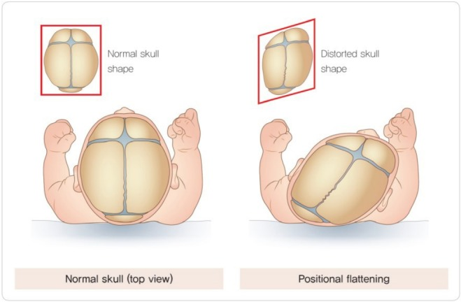

**Figure 2.1: Comparison of a normal cranial structure to a positional flattened cranial structure**

An individual is medically classified with PP through a clinical diagnosis. No radiograph is needed to conclude this, as there is a clinical suspicion of craniosynostosis, or that the condition is untreatable (20). The *National Library of Medicine* noted that the simplest method of evaluating the severity of the condition is by a physical examination, in which the diagonal lengths on each side of the head are measured using a diagonal caliper tool (21). However, there have been errors to true diagnosis due to the inaccuracy of the tool or features of the infant; it was found that error can occur up to an average of 2.2mm (24). Though in some cases, a radiography, ultrasound, magnetic resonance imaging, or computed tomography might be conducted to avoid misdiagnosis of plagiocephaly. Oftentimes the severity of the plagiocephaly can be determined when the cranial vault asymmetry index is calculated to be greater than 3.5.

Positional plagiocephaly is frequently left untreated due to physicians suggesting non-invasive practices to caretakers, reassuring them that the condition is common and is often reversible through natural practices. However, this may give the caretaker false hope as the treatments for PP may not be reversible. A 2000 study observed the psychosocial effects of untreated deformational plagiocephaly in primary school children and found that 39.7% of children with the condition received special help education that included special education assistance, physical therapy, occupational therapy, and speech therapy (29). Another psychosocial long-term effect of PP is the possibility of growing up with asymmetrical head features, such as the face, and it can be seen as unattractive to peers, resulting in a decreased self-confidence. Some individuals are also self-conscious about their head shape and are unable to conceal the flat area of their head with their hair, as some must keep or prefer shorter hair (30). Moreover, the George Institute for Public Health noticed the risk for developmental delays in the association of FHS. Infants with FHS are commonly prone to delayed motor skills, including sitting up and crawling, as well as delays in language development (31). Lastly, long-term effects include the practical difficulties of a grown individual with positional plagiocephaly. They may struggle to find helmets that fit if trying to find protective headwear, or even have the difficulty of wearing glasses if their ears are misaligned (30).

## 2.3 Demographic Affected

Positional plagiocephaly occurs in approximately 1 in 10,000 infants (32). As mentioned previously, positional plagiocephaly is an infant-related disorder and impacts infants between roughly six weeks to roughly four months old. The possibility of PP can occur to any infant that substantially is rested on their back or sides. However, several studies have indicated that there are correlations with the infant’s demographics and PP.

Based on multiple studies, the average age, sex, weight, maturity, delivery technique, and amount of parent care was analyzed to determine any correlations. PP is more common for male infants, resulting in roughly a 1.5:1 ratio between male and female. Additionally, the average age where PP is prevalent in infants around 16 weeks old. PP in infants with a gestation period of 37 weeks or greater was significantly higher than premature infants, however, this may be due to the tendency of premature births rather than PP relation. For the remaining categories, the studies varied in their results and there is no correlation between the different studies (33, 34, 35).

Regardless of the demographics of the infant, parental care or nurturing still made an impact on the development of PP. Infant’s who are left on their back or sides for a long duration or a substantial amount of time tend to develop PP more often than infants who are held or placed on their stomach occasionally. This may be due to the campaign created by the American Academy of Pediatrics (AAPA) in 1992 called “Back to Sleep” where parents were advised to put their infants to sleep only on their backs to prevent Sudden Infant Death Syndrome (SIDS) (35). That same year, there was an increase in abnormal head shape most likely due to this campaign. Since then, PP is still prominent and a need to prevent the disorder.

Currently, PP is not well defined or easy to detect. A majority of the time, it is identified initially by the caregivers when they have concerns about the infant’s head shape (36). The lack of proper assessment, diagnosis, and management for PP significantly impacts many infants later in development. Improvement in this field is needed, but that will not fix the root of the problem. Prevention included with treatment will make a significant positive impact on infant health and development.

## 2.4 Current Solutions

A significant raise of infant plagiocephaly in recent years has led to a larger demand for treatments and prevention (4). This same concern has also led current treatment methods to be questioned. Currently the simplest preventative and mild treatment measures recommended to parents are changing their child’s position while they sleep, holding their baby often, and allowing supervised “tummy time” while the child is awake. This repositioning and supervision would require near-constant watch from a parent or caregiver. For a working or otherwise busy parent, these “easy” solutions are not as easy as they seem (5).

More advanced treatments include physical therapy or home exercise programs for muscular torticollis, and a cranial helmet. Both these methods are purely for treatment after an onset of plagiocephaly symptoms. Physical therapy and home exercise is also only highly effective for treating mild deformities, and requires doctor consultation before starting the process (2). The cranial helmet is the treatment method used when less invasive methods like the changing the position of the baby, and physical therapy aren’t enough (8). The helmet will gently correct the baby's skull, and give the flat spot room to grow. Due to the heavy nature of a helmet, it is only recommended for children above 4 months of age so the neck muscles are more developed.

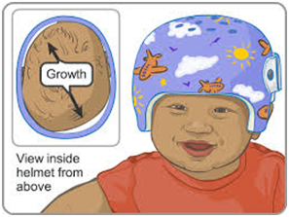

**Figure 2.2: An illustration of how a cranial helmet works to reshape an infant’s head. (41)**

One current solution to preventing plagiocephaly is the Perfect Noggin, developed by Boston Children’s (6, 9). The Perfect Noggin is a contoured surface that helps to correctly align the infant’s head and torso with a recess that cradles the infant’s head. This solution has been shown to promote symmetry and infants’ natural head shapes in multiple studies (10, 11, 12). The Perfect Noggin comes with 4 or 6 sizes so the user can replace them as the infant gets bigger. There is also a smaller version, the Crown Cradle, for premature infants (13). It is more effective if used before the infant is 10 weeks old, with its beneficial effects slowing down when started if the infant is aged 10 to 20 weeks (7). The use of this device must be monitored by the infant’s doctor, requiring check-ups on the shape of their head. This solution is expensive, retailing at $150 for 4 sizes and $170 for 6 sizes (44).

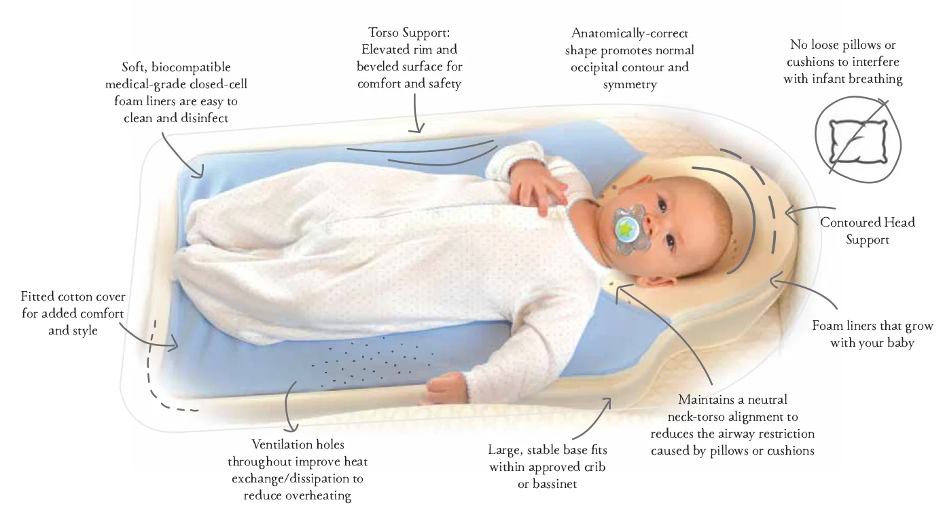

**Figure 2.3: The Perfect Noggin (42)**

Another current solution to prevent plagiocephaly are indented pillows. These can be found on shopping sites such as Amazon.com. They are usually relatively cheap and easily accessible. They are not approved by the FDA for use with infants because their use increases the risk of suffocation and SIDS (43).

# 

# 3.0 Project Strategy

This chapter will outline the preliminary plan of the team to successfully execute the project, in which it effectively supplemented the overall design process.

## 3.1 Problem Statement

The motivation for the project derived from head deformities in infants, more specifically, positional plagiocephaly (PP), or flat head syndrome (FHS), where the medical condition is common among 50% of infants (27), and is not only treatable but also preventable. Although FHS is naturally reversible with consistent practices through moving the head of the infant during sleep or increased tummy time while awake, these treatments are not guaranteed to work and oftentimes give caretakers the false hope that the condition will be fixed entirely. Additionally, these practices include regularly rotating the position of the head of the infant every hour to prevent a stationary head causing excessive force on one side of the head to flatten. However, this specific practice may be an inconvenience to the caretaker, result in inconsistent movements or placements, or even awaken the infant during sleep. Overall, the likelihood of positional plagiocephaly can decrease by preventing the development. Thus, the goal of this project is to develop an infant-safe device that periodically rotates an infant’s head while they are asleep without disruption to prevent the development of positional plagiocephaly, in which it also provides a consistency and convenience of movement for the caretaker.

## 3.2 Objectives

As part of our design process, we identified 9 main objectives for our device to fulfill to accomplish our goal of preventing plagiocephaly in infants. After deciding on the objectives, we used them to guide our design process. Three designs were ruled out because they were not able to fulfill the objectives, and another was modified to do so. Through using these design requirements, we aimed to create a device that will meet the current needs of the clients, as well as benefiting the patient and hospitals. The objectives we worked with are listed in order of decreasing importance to the project, with some being at equal levels of importance:

1. Prevention of stationary head position: Prevent infants from lying on one side of their head for more than the recommended time of 2-3 hours.
2. Safety: User will experience no harm from using this product.
3. Appropriate Dimensions: The shape and scale will be suitable for varying infant sizes.
4. Automation: Operate independently by user input after the initial input.
5. Comfort: Comfortable for the user while using the product.
6. Cost: Long-lasting and a worthwhile investment, even for low-income clients.
7. Installation: Quick and straightforward setup.
8. Portable: Ability to be easily transported to and used in multiple locations.
9. Cycle Options: Allows the user to input their preferred settings of each rotation cycle.

The first objective is that our device needs to prevent infants from laying on one part of their head for more than the recommended time of 2-3 hours. Positional plagiocephaly is caused mainly by infants laying on their backs for extended periods of time, and in order to prevent it our device has to rotate their head position at set intervals. Our device utilizes set intervals at which it will rotate the infant’s head, in order to prevent positional plagiocephaly.

The second objective, rated as important as the first, is that our device must be safe for both adult and infant users. In order to make the device safe for an infant, we must make sure that there are no stray wires or tubes of any sort that the baby could get caught on. It is also necessary that the control panel for using the device is not accessible to the infant, so they cannot activate or deactivate the device unknowingly. All of these problems will be considered in order to make the device safe for use.

The third objective is a tier below the first two objectives with regards to importance to our design. This objective is that the device must have appropriate dimensions. The shape and scale of the design will be suitable for infants ranging from 0 to 6 months. Infants grow fast, so it is important that the device will be usable for a period of the infant’s life that is balanced with its cost.

We ranked the fourth objective at the same level of importance as the third. This objective is that the device will be automated. An automated device will operate independently of additional user input. The user will have to turn the device on and input what cycle option they would like, but after that the device will operate on its own. This is to minimize the amount of time that the caretaker has to spend looking after the infant. Without automation, the caretaker would be going into the infant’s room every 1-2 hours and rotating their head. With an automated device, the caretaker only has to check on the infant briefly at certain intervals. We want this device to be useful to busy caretakers, such as in a hospital.

Our fifth objective is ranked at the same level as the third and fourth objectives and it is to make the device comfortable for the infant. If the device is loud to the infant they will not be as restful during their sleeping times, which would cause disturbances that the caretaker has to deal with. Our aim is to reduce the amount of time a caretaker has to spend tending to their infant. By creating a device that is quiet the infant will be allowed to have restful, undisturbed sleep while also preventing positional plagiocephaly.

The sixth objective is one level of importance below the last three objectives, it is to take the cost of the device into account when making it. Infants grow very fast, and we decided to design the device to be usable for a span of 6 months for the average infant. By designing a device that can be used over multiple months of an infant’s early childhood, the consumer is better able to justify the cost of the device.

A tier below the sixth objective is the seventh, which is to design a device that has a quick and straightforward installation process. Devices that have complicated setup deter the consumer from using them. We designed the device to be installed in less than 5 steps, so that many different consumers can feel confident in their ability to install and use the device.

The final tier of importance contains the eighth objective, for the device to be portable. The ability to be transported to and used in multiple locations is important because it provides flexibility to the consumer. A portable device is also more likely to be used consistently, which will help prevent positional plagiocephaly. We also wanted to consider low-income families, who may not have a dedicated crib for their infant, so we designed the device to be usable in multiple different locations.

The ninth and last objective, in the same tier as the eighth, is to provide the user with different cycle options. Our device will utilize set intervals of 45, 60, and 75 minutes to gently reposition the infant’s head in order to prevent positional plagiocephaly. By creating interval options, the caretaker can adjust the device to align with how long their infant sleeps.

## 3.3 Management Approach

Due to the time constraints of the project and demand to complete a functional medical device in 7 weeks, the strategic approach of the project included the generation of a Gantt Chart and Work Breakdown Structure.

### 3.3.1 Gantt Chart

Seen in Figure 3.1 below. The Gantt Chart contains all necessary components to complete the project, including the initial steps, design process, production progress, conducted testings, and report construction. As there may be delays in the project progress, the Gantt Chart may be updated to reflect these setbacks. However, the team constantly refers to this chart to ensure that checkpoints are being met with sufficient time for the remaining steps of the project.

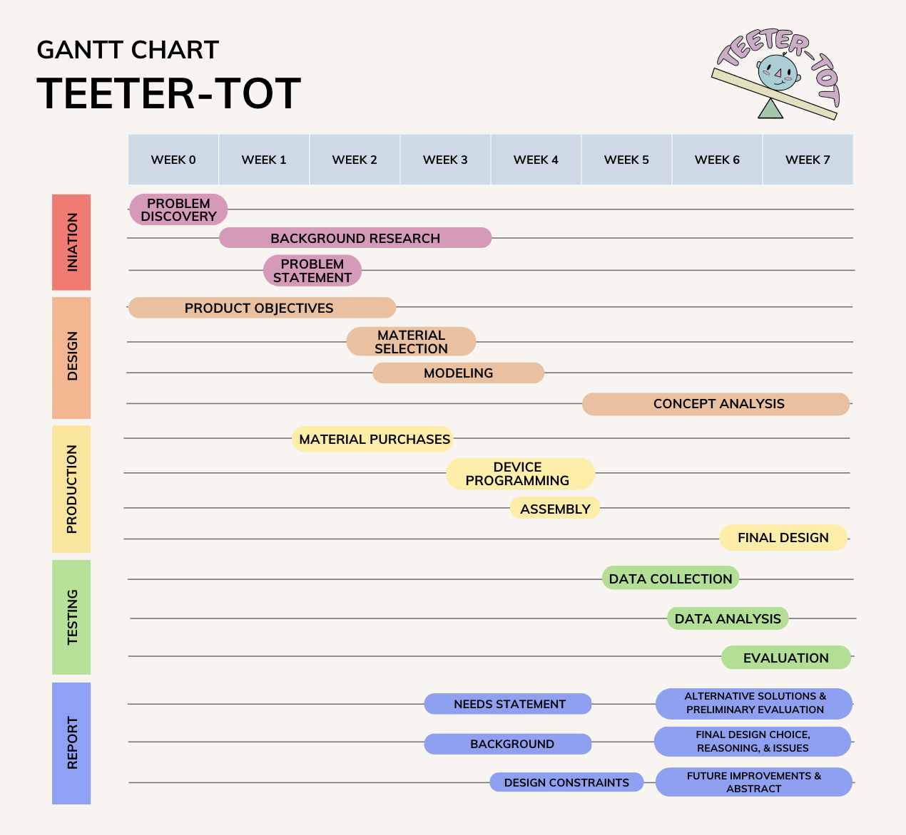

**Figure 3.1: Project Gantt Chart**

### 3.3.2 Work Breakdown Structure

Moreover, the Gantt Chart provides guidance for the timeline of the project for the Work Breakdown Structure, seen in Figure 3.2 below. Each major step of the project is broken down into the necessary steps to complete in order to move onto the next step. A factor of the Work Breakdown Structure is unable to be expressed in the Gantt Chart is when there is a failure in the evaluation of testings, we should return back to the design process to possibly create a new version of the model.

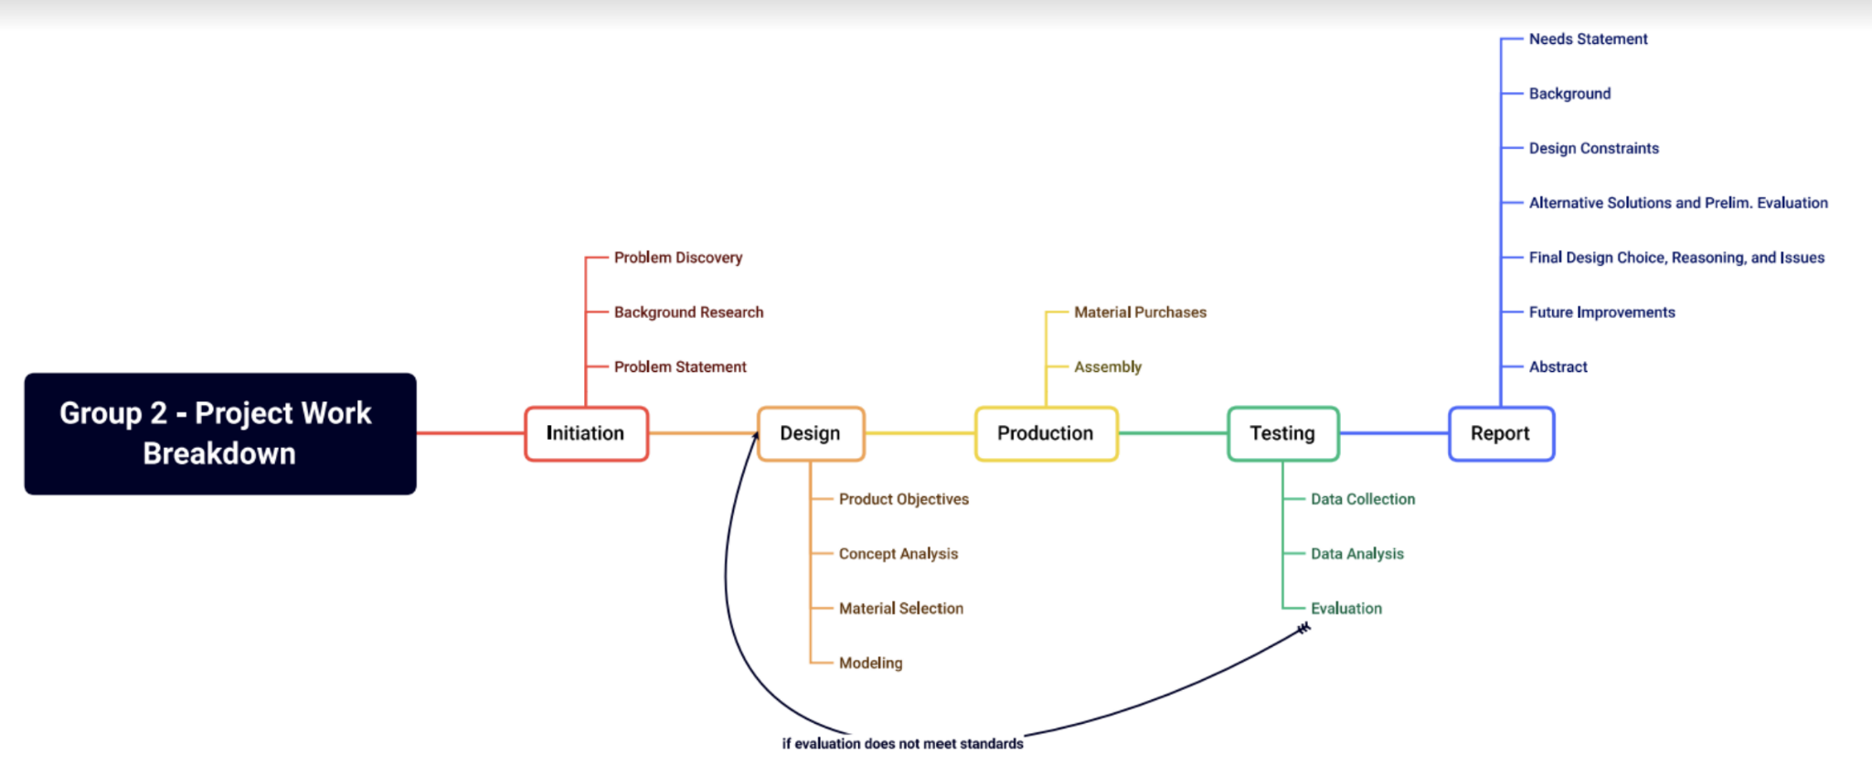

**Figure 3.2: Work Breakdown Structure**

# 

# 4.0 Design Process

This chapter outlines the developmental design process of the product through meeting all project objectives, including the functions, conceptual brainstorming, preliminary designs, and final design.

## 4.1 Functional Blocks

Our intended design contains functional blocks pertaining to three disciplines of engineering: materials, mechanical, and electrical. Table 4.1 below outlines the functional blocks and the specifications pertaining to each. The functional blocks meet all nine objectives, and are further incorporated in each test.

**Table 4.1: Functional Blocks**

| **MATERIALS** | **MECHANICAL** | **ELECTRICAL** |
| --- | --- | --- |
| The materials used in the device will be comfortable and safe for the user, and flexible and easy for the consumer to install. | The device will ensure that the head of the infant does not rotate more than the unsafe amount. The device will also be constructed to safely store electrical units for the safety of the infant. | The device will include automations and user-friendly options for variation in cycle frequencies. |

## 4.2 Technical Specifications

The technical specifications for the product were synthesized from our nine main objectives to create four specifications. All four technical specifications comprise one of the objectives throughout: the cost for the consumer is considered in all the specifications. Table 4.2 below displays the technical specifications with its relevant technical specifications.

**Table 4.2: Technical Specifications**

| **Objective** | **Technical Specification** | | |
| --- | --- | --- | --- |
| **An automated system that will gradually change the head position of an infant, without rotating the head more than 90 degrees, with three cycle options.** | Each cycle transition does not take less than 3 minutes. | Head does not rotate more than 90 degrees during each cycle transition. | Device will rotate the infant’s head at 3 frequencies: 45, 60, and 75 minutes. |
| **A device that supports the head of a 0-6 month old infant and produces less than 60 dB of sound.** | The active device does not exceed 60 dB of sound. | Device will fit a range of infants ages 0 to 6 months. |  |
| **The device contains an easy-to-follow step-by-step guide with no more than 5 steps to install.** | No additional assembly required for the user. | A picture guide for easy set-up with less than 5 steps. |  |
| **A compact, battery powered device, that can be removed from the sleeping area to be transported and utilized in any infant-sized, flat sleeping location.** | The electronics can be fully powered through battery usage. | The device can be used on any infant-sized sleeping location. | The device can easily be folded up for transportation. |

The first technical specification combines the objectives of the prevention of a stationary head position, automation, and cycle options. The technical specifications in relation to this technical specification is developing the device so that each cycle takes no longer than three minutes to achieve. In other words, it would only take three minutes for one side of the pad to fully inflate. Another specification in this block is that we need to make sure that the head does not rotate greater than 90 degrees when one side of the pad is inflated or deflated. Lastly, we want the device to be user friendly and allow the consumer to be able to determine their preferred rotation frequency.

The second technical specification combines the objectives of having the appropriate dimensions that can fit an average sized infant and provides comfort for the user. Thus, the technical specifications include making sure that the operating device is not louder than 60 dB so that it does not disturb a sleeping infant and that the pad will be large enough to support the rest and movement of an average infant’s head who is six months old or younger.

The third technical specification obtains the objectives of installation. Thus, this device will be easy to install for use for the consumer as we will design the device so it does not need any additional assembly for the user. Moverover, the product will also include a step-by-step guide with images that can easily direct the consumer in the setup process. Ideally, this guide should not include any more than five steps for an easy installation for the user.

The last technical specification contains the objectives of being portable and safe. To allow for the device to be portable, we hope to have the device to be able to fold so it can be easy for transportation and small enough to be used in any infant-sized flat sleeping location. For the device to be safe, a technical specification was made to make sure that the electronics were not to be touching and disturbing the user.

## 4.3 Conceptual Brainstorming

Through extensive literature review, it is known that the causes that further advance the development of flat head syndrome are due to, but not limited to, remaining stationary in a prone position during infant skull development. Additionally, there are many current solutions that treat FHS, such as a cranial helmet to be worn for months during the first few years of a baby’s life, but there are not many medical devices that exist that prevent the development of FHS. Utilizing these treatments are not always guaranteed to fix FHS, and sometimes even using these devices throughout the vital developmental stages of a young child may have great impacts towards their overall psychosocial development. Thus, we wanted to design a product that can prevent the development of the syndrome, which also will prevent the treatments in the future.

Because the device should not promote keeping the head of the infant stationary in one position for a long time, we wanted a device that would be able to move the head automatically so that the caretaker does not need to continuously move the position of the infant and possibly disturb the infant during sleep. We know that the head of the infant can rotate with light pressure under the head directed at an angle. Therefore, a double-sided pad that is made of polyethylene (PVC) that alternates to be filled with air to naturally encourage the infant to rotate their head from one side to another, preventing the infant to remain in a stationary position of the head. A safety concern of current medical devices that prevent FHS is that many of them have a high chance of the infant accidentally rolling onto its stomach and eventually experience sudden infant death syndrome (SIDS) as its head would fall into a divet in the product. While brainstorming our device, we wanted to prevent the occurrence of SIDS by making the device flat, and adding no elevation to the head. Another safety concern was making sure that the electronics of the device would be well-contained so that the infant would not be disturbed or potentially harmed by exposure to the materials of the device.

Ultimately, preliminary designs considered all nine objectives of this project, but all varied in how well each objective was considered. The following section outlines the preliminary designs of the product prior to developing the final design.

## 4.4 Preliminary Designs

After researching the medical concern of focus and the requirements, and brainstorming the objectives, technical specifications, and technical specifications of our product, our team developed three preliminary designs that contain the needs and wants of the product.

### 4.4.1 Preliminary Design 1: Inflatable Rotating Cushion

Our team’s first preliminary design for a plagiocephaly prevention device was a portable, inflatable pillow-based cushion to automatically rotate an infant’s head while sleeping. This device is a two-section inflatable pillow with the setting control panel attached to the back of the pillow, so no cord is necessary. The control panel contains the different desired settings in between two air vents to allow each side of the pillow to be inflated or deflated. The height and shape of the device will be safe and comfortable for the infant. Finally, this device is battery-powered, allowing for portability and accessibility in varying locations.

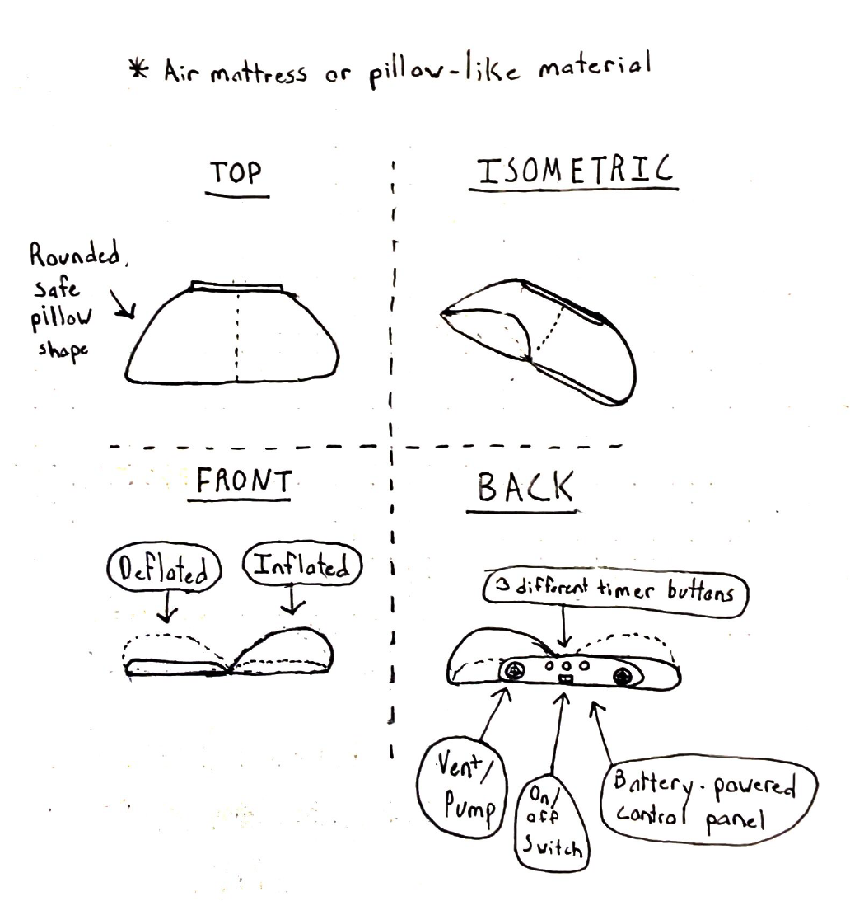

**Figure 4.1: Sketch of Preliminary Design 1**

### 4.4.2 Preliminary Design 2: No-Stress Infant Car Seat

Our second preliminary design to help prevent plagiocephaly is targeted specifically towards longer car rides. Its purpose is to improve on the current design of booster seats in cars that aren’t particularly made for infants aged 0-6 months old. This car seat would lie the infant horizontally and allow free movement to the infant’s head. The design would feature secure straps both to the infant’s body, and the car seat itself. The purpose of the secure straps would be to prevent jostling and bouncing during car rides. The section of the car seat would be flat and comfortable to promote movement of the head, and eliminate all safety concerns like suffocation. This car seat will allow for natural and comfortable infant sleep, and help eliminate worry for infants during long rides on a bus, car, or train.

### 4.4.3 Preliminary Design 3: Mechanical Arm Mechanism

The third preliminary design that we created makes use of a mechanical arm mechanism to rotate the infant's head. By rotating the infant’s head on set intervals, positional plagiocephaly can be avoided. There are padded boards on each side of the device that are attached to the baseboard at the center. The boards are lightly padded with cotton for the comfort of the infant. The mechanical arm lifts up the outer edges of the padded boards, one at a time, in order to rotate the infant’s head. On either side of the baseboard there are motors contained in plastic housings with tracks for the mechanical arms to move up and down on. On the back of the device there is a control panel that has different cycle options and a cord to power the device. There will be two cycle options: rotation every 60 minutes and every 75 minutes. Control over the cycle options allows for the caretaker to adjust the cycle depending on how long their infant usually sleeps for.

## 4.5 Design Decision

The final design from the three preliminary designs that were brainstormed were determined by a pairwise comparison chart and a Pugh concept selection matrix. Reiterating the nine objectives of the final design, the prevention of a stationary, automatic, size, comfort, portability, cycle options, safety, installation, and cost, (also referenced in Chapter 3.2 Objectives), we wanted to incorporate all of these objectives effectively into our final device. Table 4.3 exhibits a pairwise comparison chart, where the objectives were ranked, in cross-referencing to the other objectives. The scoring system for the pairwise comparison chart was given the assigned values: 1 if the objective is of greater importance than the other, 0.5 if the objective is of equal importance to one another, and 0 if the objective is of lesser importance.

**Table 4.3: Pairwise Comparison Chart**

|  | Prevention of stationary head position | Automatic | Size | Comfort | Portable | Cycle Option | Safety | Install | Cost |
| --- | --- | --- | --- | --- | --- | --- | --- | --- | --- |
| Prevention of stationary head position |  | 1 | 1 | 1 | 1 | 1 | 0.5 | 1 | 1 |
| Automatic | 0 |  | 0.5 | 0.5 | 1 | 1 | 0 | 1 | 1 |
| Size | 0 | 0.5 |  | 0.5 | 1 | 1 | 0 | 1 | 1 |
| Comfort | 0 | 0.5 | 0.5 |  | 1 | 1 | 0 | 1 | 1 |
| Portable | 0 | 0 | 0 | 0 |  | 0.5 | 0 | 0 | 0 |
| Cycle Options | 0 | 0 | 0 | 0 | 0.5 |  | 0 | 0 | 0 |
| Safety | 0.5 | 1 | 1 | 1 | 1 | 1 |  | 1 | 1 |
| Installation | 0 | 0 | 0 | 0 | 1 | 1 | 0 |  | 0 |
| Cost | 0 | 0 | 0 | 0 | 1 | 1 | 0 | 1 |  |

After the pairwise comparison chart, it was quantitatively deemed that the objectives were ranked in the following order:

1. Prevention of stationary head position
   1. Safety
2. Appropriate Dimensions
   1. Automation
   2. Comfort
3. Cost
4. Installation
5. Portable
   1. Cycle Options

Some objectives were found to be equal in importance, resulting in five different rankings. The prevention of a stationary head position and safety objectives were ranked at the most importance; the appropriate dimensions, automation, and comfort objectives were ranked at the second-most importance; the cost was the third-most importance; the ease of installation was ranked at the fourth-most important; and the portability and choice of cycle options were ranked at the least importance of the objectives.

With these rankings in objectives, we have weighted each concept of the design: the objective component of the design of the most importance was weighted with five points, and the least important objectives were weighted with one point. The Pugh Concept Selection matrix, Table 4.4, included a baseline comparison of the Perfect Noggin, the most current medical device on the market with similar goals, but it does not entirely meet our design requirements and objectives. Each preliminary design was given a score: 0 if the concept of the design is not better but not worse than the baseline device, 1 if the concept of the design is better than the baseline device, and -1 if the concept of the design is worse than the baseline device.

**Table 4.4: Pugh Concept Selection Matrix**

| **Criteria** | **Weight** | **Baseline** | **Preliminary Design** | | |
| --- | --- | --- | --- | --- | --- |
| Perfect Noggin | Design #1 | Design #2 | Design #3 |
| Prevention of stationary head position | 5 | 0 | 1 | 0 | 1 |
| Safety | 5 | 0 | 0 | 1 | -1 |
| Automation | 4 | 0 | 1 | 0 | 1 |
| Appropriate Dimensions | 4 | 0 | 1 | 0 | 1 |
| Comfort | 4 | 0 | 1 | 0 | 1 |
| Cost | 3 | 0 | 1 | -1 | -1 |
| Installation | 2 | 0 | -1 | 0 | -1 |
| Portable | 1 | 0 | 1 | 1 | 0 |
| Cycle Options | 1 | 0 | 1 | 0 | 1 |
| Sum of Positives | | 0 | 22 | 6 | 18 |
| Sum of Neutrals | | 0 | 0 | 0 | 0 |
| Sum of Negatives | | 0 | 2 | 3 | 10 |
| Total | | 0 | 20 | 3 | 8 |

After the evaluation of all three preliminary designs, the Pugh Concept Selection matrix quantified the improvements with weight to the importance of the concepts incorporated into the device. Preliminary Design 1, the Inflatable Rotating Pillow, was found to have the highest total, meaning that it would have the most improvement for the goal of the device but the prevention of FHS. Thus, we will be proceeding with the first design to develop the device, but as we run into roadblocks, the device may, and was, shifted in areas in which we believe that the device would be more improved.

# 

# 5.0 Final Design

This chapter outlines the final design of the device, incorporating all requirements and objectives planned previously. The device contains material, mechanical, and electrical components that when together, overcomes all functional blocks (stated in Chapter 4.1) and technical specifications. More importantly, the final design of the device will be tested to determine the functionality of the device and confirm the concept of the device.

## 5.1 General Overview

Our final design for our product is a two-sided, automatic, inflatable pad that is comfortable, safe, and non-disruptive for the infant to prevent positional plagiocephaly. This product will include a battery-powered source for portability, a safety strap to be wrapped around the infant’s bed to provide security, and multiple cycle options to inflate the pads at various frequencies. Figure 5.1 presents the final design of the device.

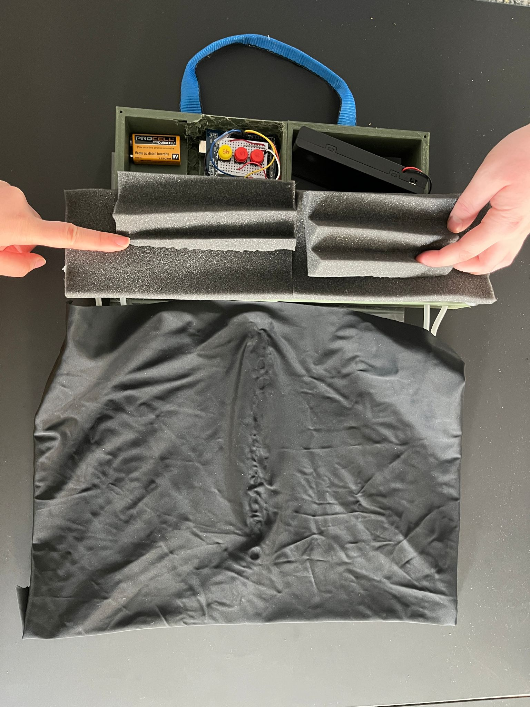

**Figure 5.1: Final Design**

The user will need to insert batteries to power the device. Next, the user will need to install the device onto the infant-sized sleeping location, securing the device with the underbed strap. The operator will then need to turn on the device and choose the rotation time manually. The remaining features are automatic and will occur on a set timer while the infant is resting on the device.

The parts and materials needed for the device were organized into three different aspects, specifically mechanical, electrical, material aspects. The mechanical aspects consist of the construction and organization of the device. The electrical aspects consist of the power, programming, and wiring of the device. Finally, the materials aspects consist of the adhesion and comfort of the device.

## 5.2 Material Components

Different material types were researched and tested to determine the best materials to use for each component of the device. The materials that were researched pertained to the following components of the device:

* Inflatable pillow
* Control panel
* Base board
* Cover
* Straps
* Glue
* Testing Model

The following sections investigate the processes to determine the preliminary and final material selection of the device.

### 5.2.1 Inflatable Pad and Tubing

The inflatable pad’s purpose is to intake air and change volume over in order to rotate the infant’s head. Two pads were used to provide a seam in the middle of the device to prevent potential suffocation. Figures 5.2 and 5.3 display the shape and dimensions of these pillows.

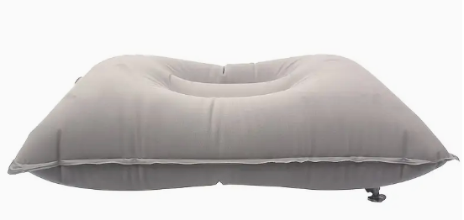

**Figure 5.2: Shape of the inflatable pad**

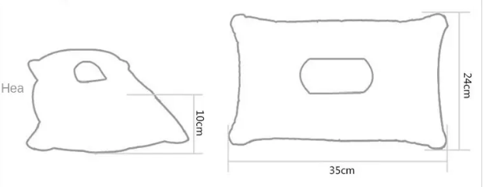

**Figure 5.3: Dimensions of the inflatable pad**

In addition to the pillows themselves, several other sources of airflow are needed to accurately and routinely adjust the volume of the pillows. In each pillow, two incisions are made near the corners of the pillows on the shorter sides about an inch apart. This is to create small holes for plastic tubes to be inserted, secured, and air-tight to the pillows. The tubes are eventually connected to the pump system.

### 5.2.2 Control Panel

The control panel design was made of polylactic acid (PLA) filament. This type of filament is one of the more popular types used for extrusion-based 3D printing. This is due its ability to be printed at a low temperature as well as not requiring a heated need to be printed on.

In addition to PLA filament, acoustic foam was used to reduce the noise of the pumps when the device is activated. This was added to the control board itself after it was printed. In order to reduce the sound of the device, we decided to implement a layer of soundproof foam around the pump slots to cover them as much as possible.

### 5.2.3 Arduino and Accessories

The electrical components of our design were run through an Arduino Uno and featured four 4.5 volt air pump and vacuum DC motors, three buttons, two power sources, one power switch, one breadboard and a four-channel relay board.

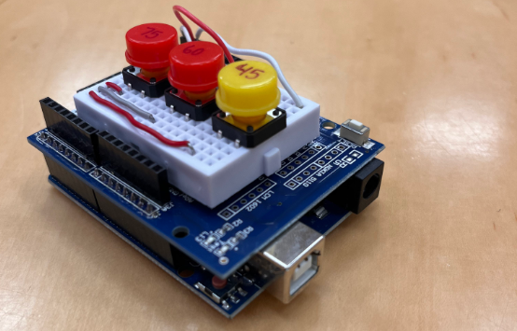

**Figure 5.4: Arduino used in prototype with three buttons**

The Arduino Uno was chosen due to its user-friendly features, high versatility and 14 available digital input/output switches. Three buttons were needed to fulfill our cycle options of 30, 45, and 60 minute cycles. We labeled each button with the duration of the cycle it controlled. The power-switch is utilized in line with the 9 volt battery to allow the user to switch the activation of the Arduino on and off. Only one breadboard was used in order to save space within the control board as seen below.

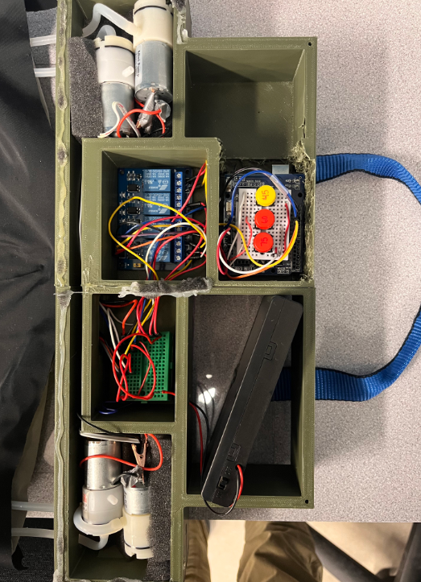

**Figure 5.5: Most components within the control board**

Various wires were used to connect everything to each other. Alligator clips were needed to connect to the pumps because there was no built-in connection. The alligator clips were also soldered to each pump in order to prevent disconnection and possible shorting of the pumps.

The relay board was another integral part of the prototype. A relay board is an array of relays and switches that contains inputs and output terminals. They are commonly used to control voltage supply. In this case, the relay board was used to allow a stronger power supply to be used for the air pumps. A four-channel relay board was used because four pumps needed to be controlled, and it saved space compared to four individual relay boards.

### 5.2.4 Power Sources

Two power sources were required for the circuit; one 12 volt power supply that was linked to the four pumps, and one 9 volt battery that powered the Arduino Uno and relay switch. The 12 volt battery pack was chosen because it outputs enough current to power all pumps for a large amount of time. This battery pack also has a built-in on-off switch which was useful during testing. Downsides to this pack are size, and tendency to overheat when used too often. As seen in the full control board picture above, the battery pack sticks out of the top. This disallowed the covering of the control board with the original plastic cover. Overheating was another problem that occurred during testing. When activated too often, the output voltage would slowly begin to decrease until the pumps were too weak to fully fill each pad. The pack was able to last about an hour of testing before overheating. If a full product was to be made this pack should be replaced with a smaller battery that can last longer.

The 9V battery was much better size-wise than the 12V battery pack. It fit very well into the control board with no hassle. It did not have a built-in on-off switch, so one was purchased to be used in-line with this battery. This battery faced a similar overheating issue to the battery pack, but to a greater degree. This battery worked well for 3 to 4 tests before the voltage got weak, and was unable to fully activate the relay board. This battery would need to be replaced with a similar-sized longer lasting battery in future developments.

### 5.2.5 Pumps

Air pumps were used to intake and release air into the device. These pumps were located in the control panel of the device and covered with acoustic foam to reduce the overall noise level produced when functioning. Four air pumps/vacuums were needed because the specific pumps we chose were unable to switch polarity through the code. This meant that one pump had to inflate the pillow, while the other had to deflate the pillow on each side, totaling four pumps. These pumps were powered by a separate power source due to the amount of power needed. Figure 5.6 is the pump that was used in the final device.

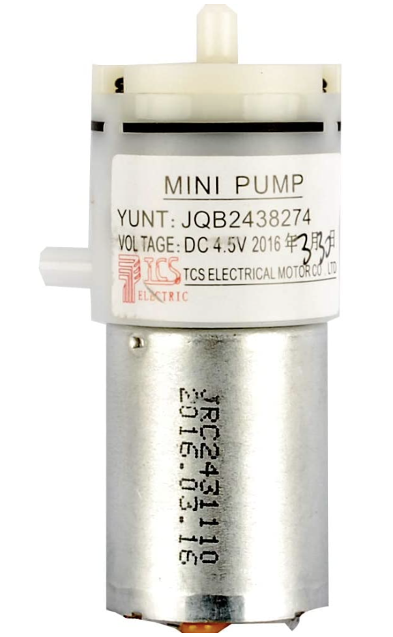

**Figure 5.6: Air pump/vacuum for final device**

Each pump costed $8.99. The pump had the capability of pumping air and removing air with the attachment of two holes for air tubes. The DC voltage of the pump was 6V, with a current of 400mA. The gas flow rate was 3.2 L/minutes. Additionally, for easy direction of airflow, tubes were used.

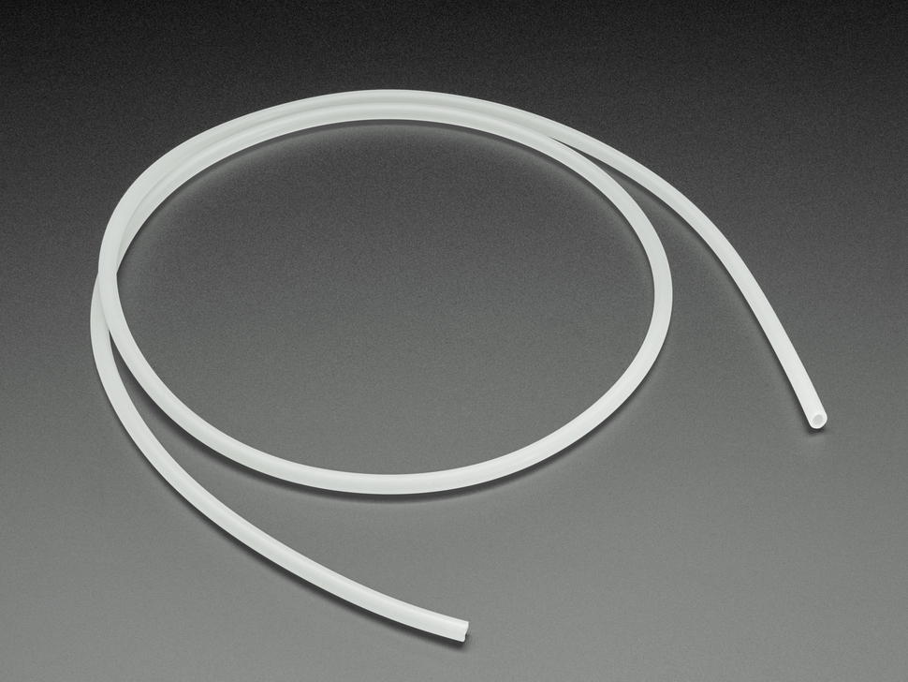

**Figure 5.7: Air pump/vacuum tubing**

Figure 5.7 displays the tubing used to attach to the pumps. Two 1 meter silicone tubes, with a diameter of 3mm, were purchased at $2.50 each. The tubes were cut into four 3-inch lengths to be used for the final prototype.

### 5.2.6 Device Baseboard

The device baseboard was used to attach the control board close to the inflatable pads. We used a polycarbonate sheet and cut it down to 43.25 by 32 cm. This material was selected based on availability in the lab as well as for being a sturdy material that is not prone to breaking.

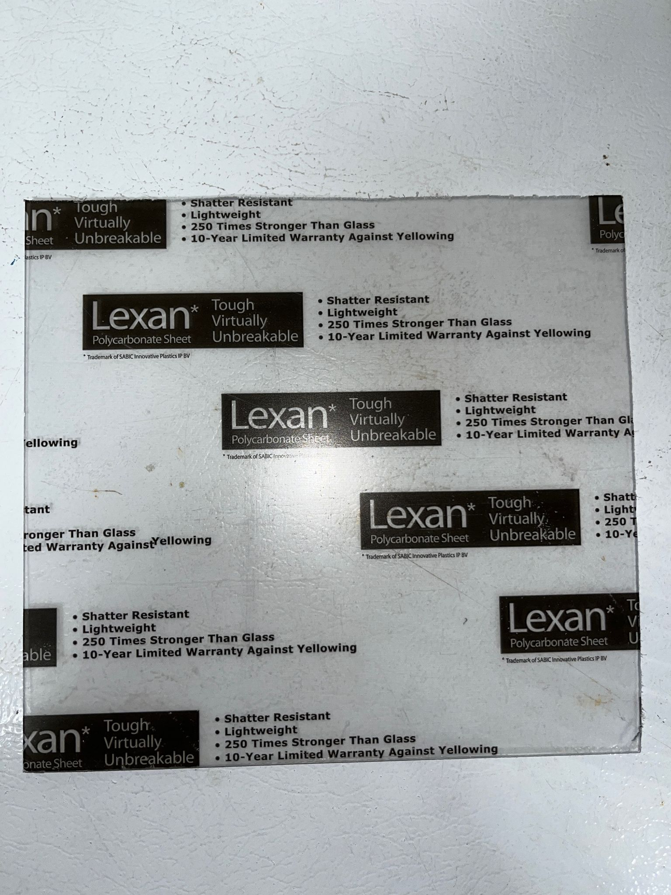

**Figure 5.8: The section of the polycarbonate sheet that we used for the device.**

### 5.2.7 Cover

For the cover we used an elastic material that we found in the lab scrap shelf. The device needed a material that would stretch with the inflation of the pads and not leave any excess material when deflated, to prevent the infant from getting caught in it.



**Figure 5.9: The inflatable pads with the cover material**

### 5.2.8 Strap

The purpose of the strap is to ensure the safety of the consumer and user of the product by securing the device onto any flat surface. So this strap is adaptable to fit on any surface, we wanted an elastic strap so it can stretch on any surface. Thus, the lab scrap box contained a reusable cinch strap, Figure 5.**7**, that provides that elastic and durable component.

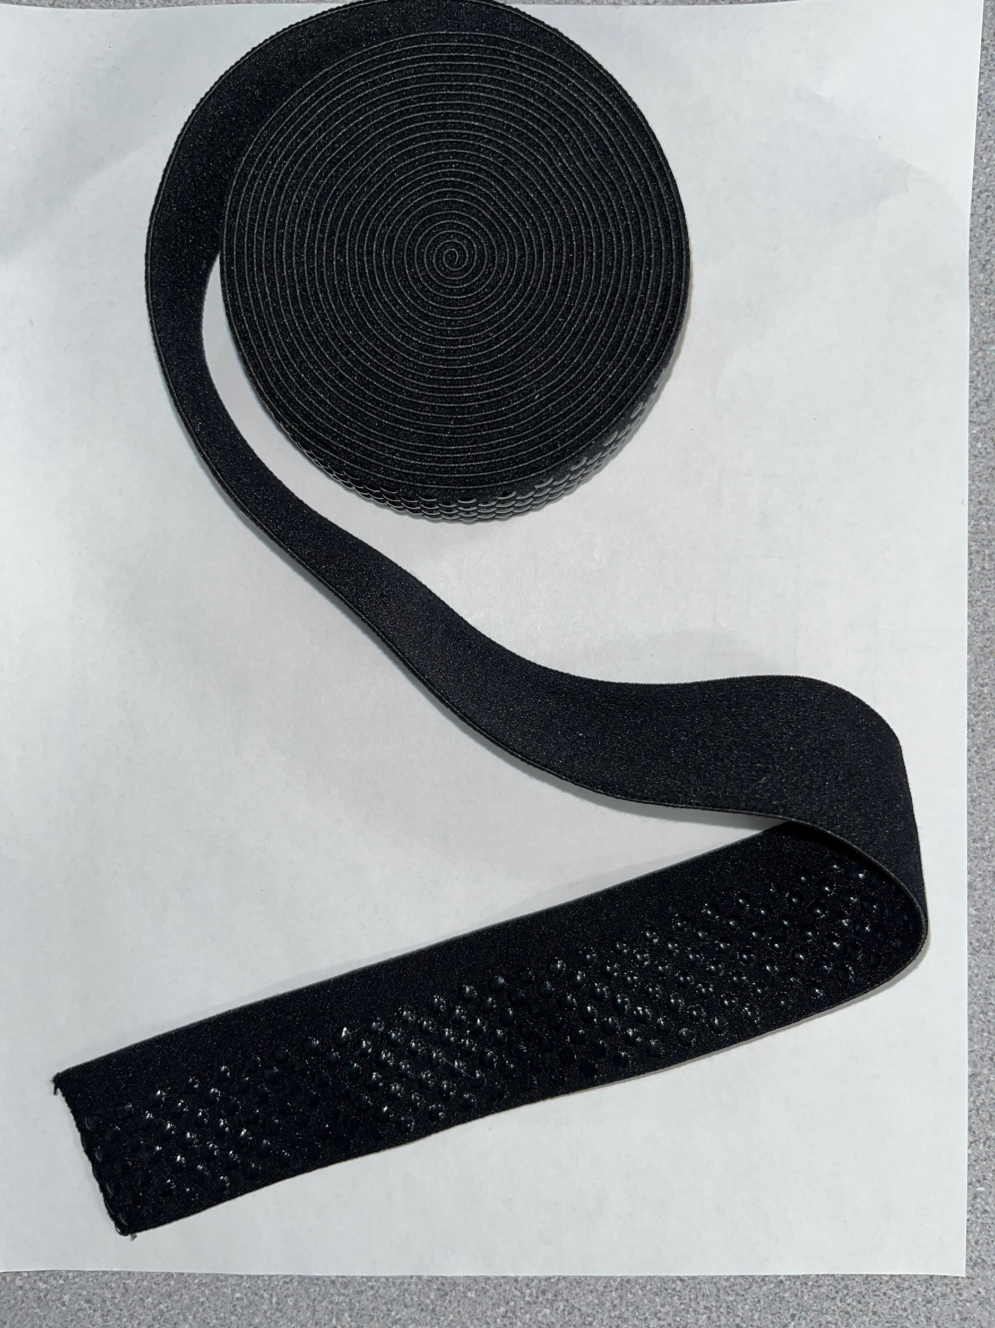

**Figure 5.10: Elastic security strap**

The length of the strap that was used had a width of 3.8 cm and length of 65.5 cm, which was deemed the best length to ensure secure attachment to an average-sized crib.

### 5.2.9 Handle

Unlike the material used for the strap, the material for the handle of the device needed to be inelastic and sturdy, where it is able to withstand the weight of the entire device. The material found in the lab scrap box is polyester webbing, Figure 5.8, where it will be durable enough to withstand the weight of the device.

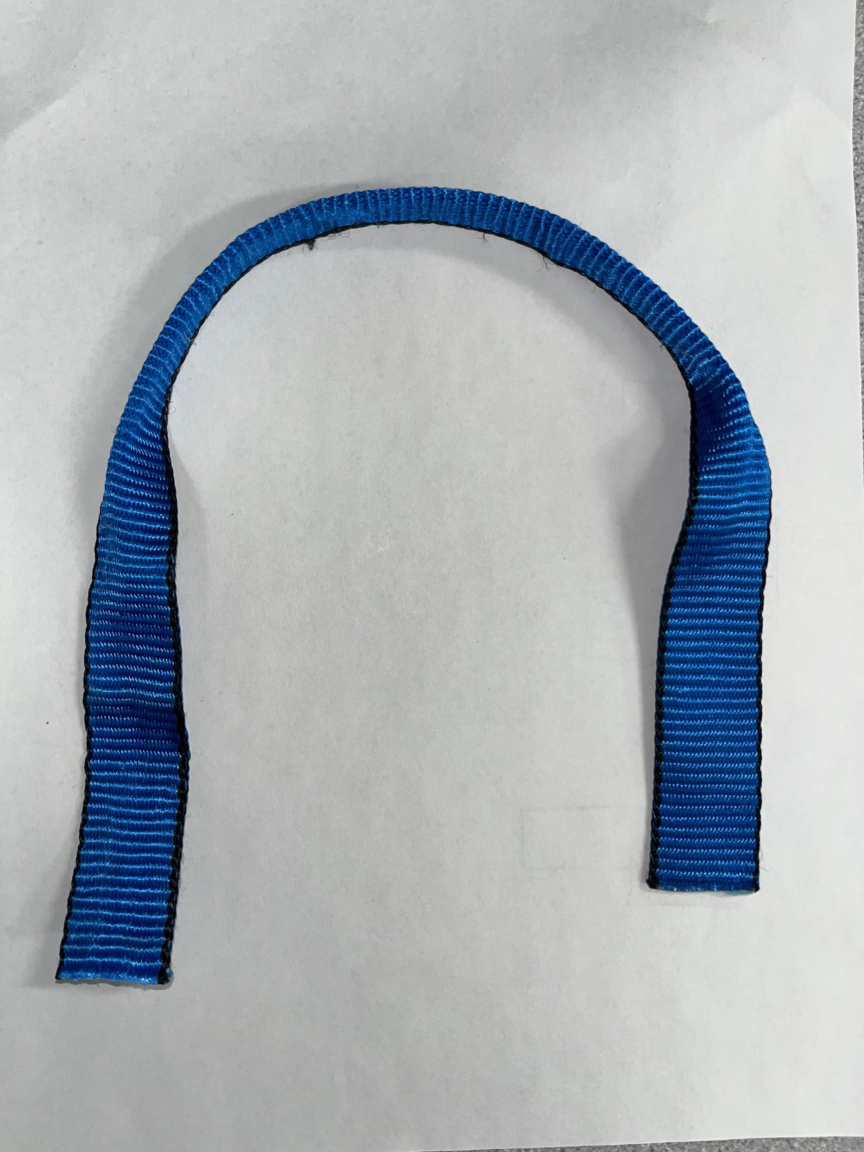

**Figure 5.11: Handle**

The handle has a width of 2.5 cm, and was cut to a length of 41 cm to make the device easily portable for the consumer and user. The middle of the handle was folded lengthwise and secured with hot glue to ensure additional durability of the handle.

### 5.2.10 Glue

To secure all components of the device together through the baseboard, durable glue was necessary. Three different types of glue were observed: hot glue, AirStop glue (Figure 5.9 left), and Gorilla Epoxy glue (Figure 5.9 right). The materials that are to be secured to the baseboard is the control board made of a common 3D filament, the elastic strap, and the polyester webbing handle.

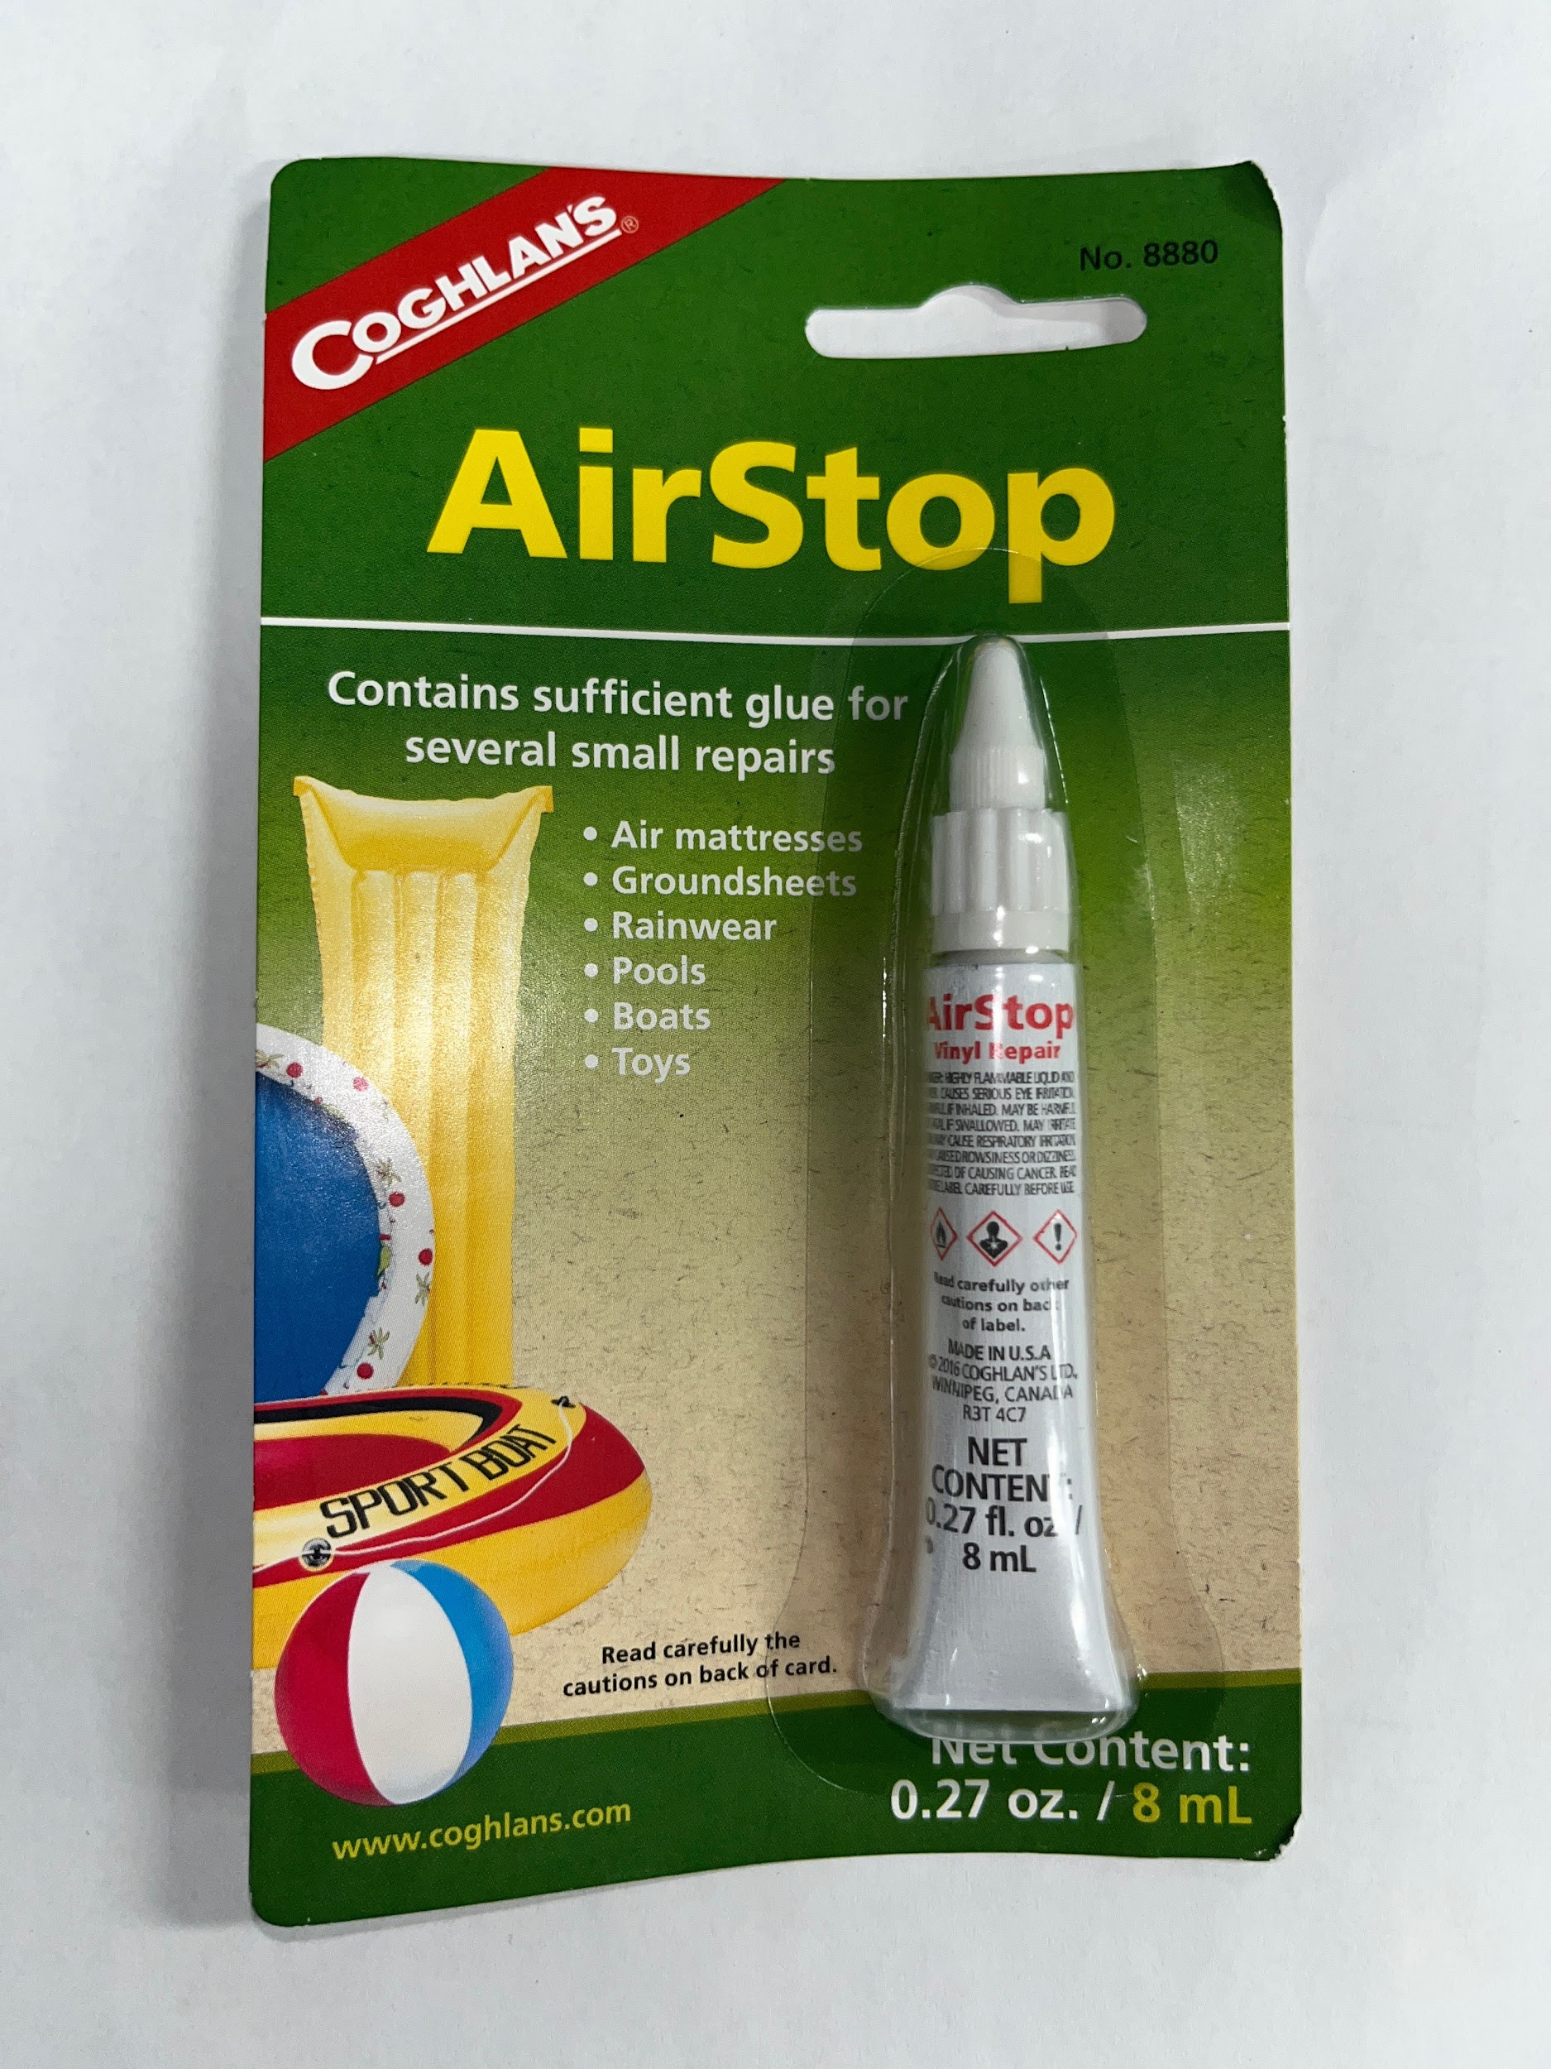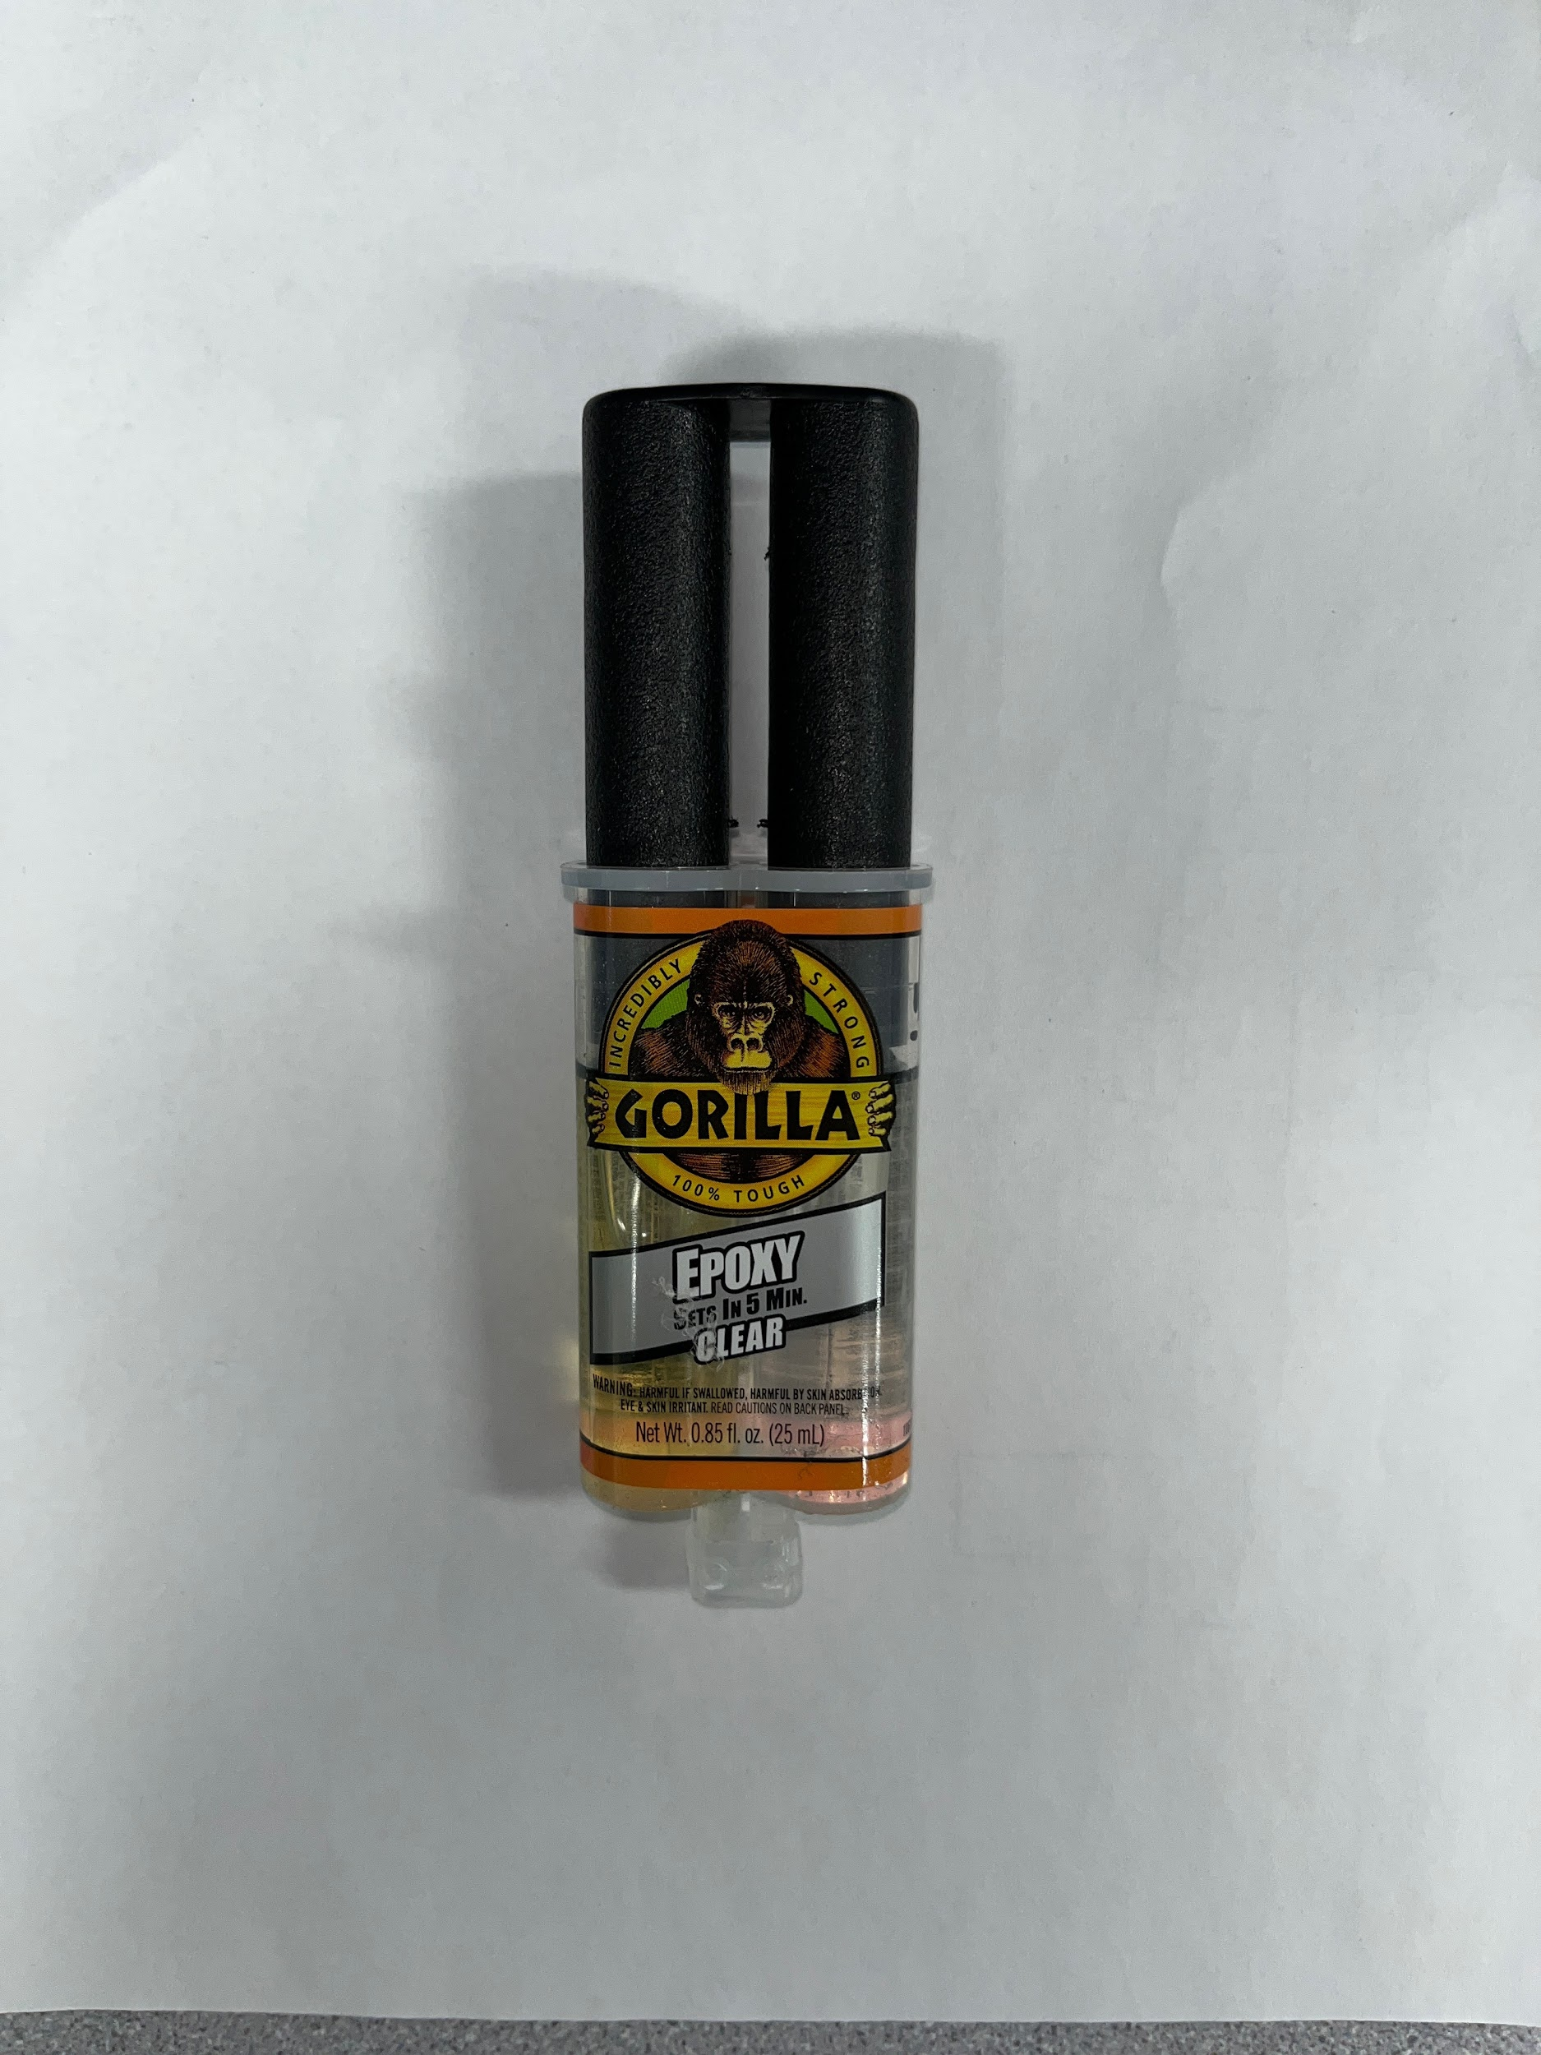

**Figure 5.12: Glue options. AirStop (left) and Gorilla Epoxy (right)**

Prior research was completed to understand any possible toxicity of the materials with the glue, however, no severe toxicity was found. Additionally, since the strap and handle materials were found in the scrap box, we are not entirely sure the composition of each material. Thus, a glue test was conducted to understand the durability and security of each glue type with each material onto the material of the baseboard, or polycarbonate.

The test was conducted by applying a small amount of glue to a sample of the baseboard and placing a sample of each material onto the glue. The material to represent the material of the control board was a 3D-printed scrap piece found in the lab scrap box. After glue application, the glue and materials were set to dry for 24 hours. Figure 5.10 exhibits the tested materials on the baseboard sample.

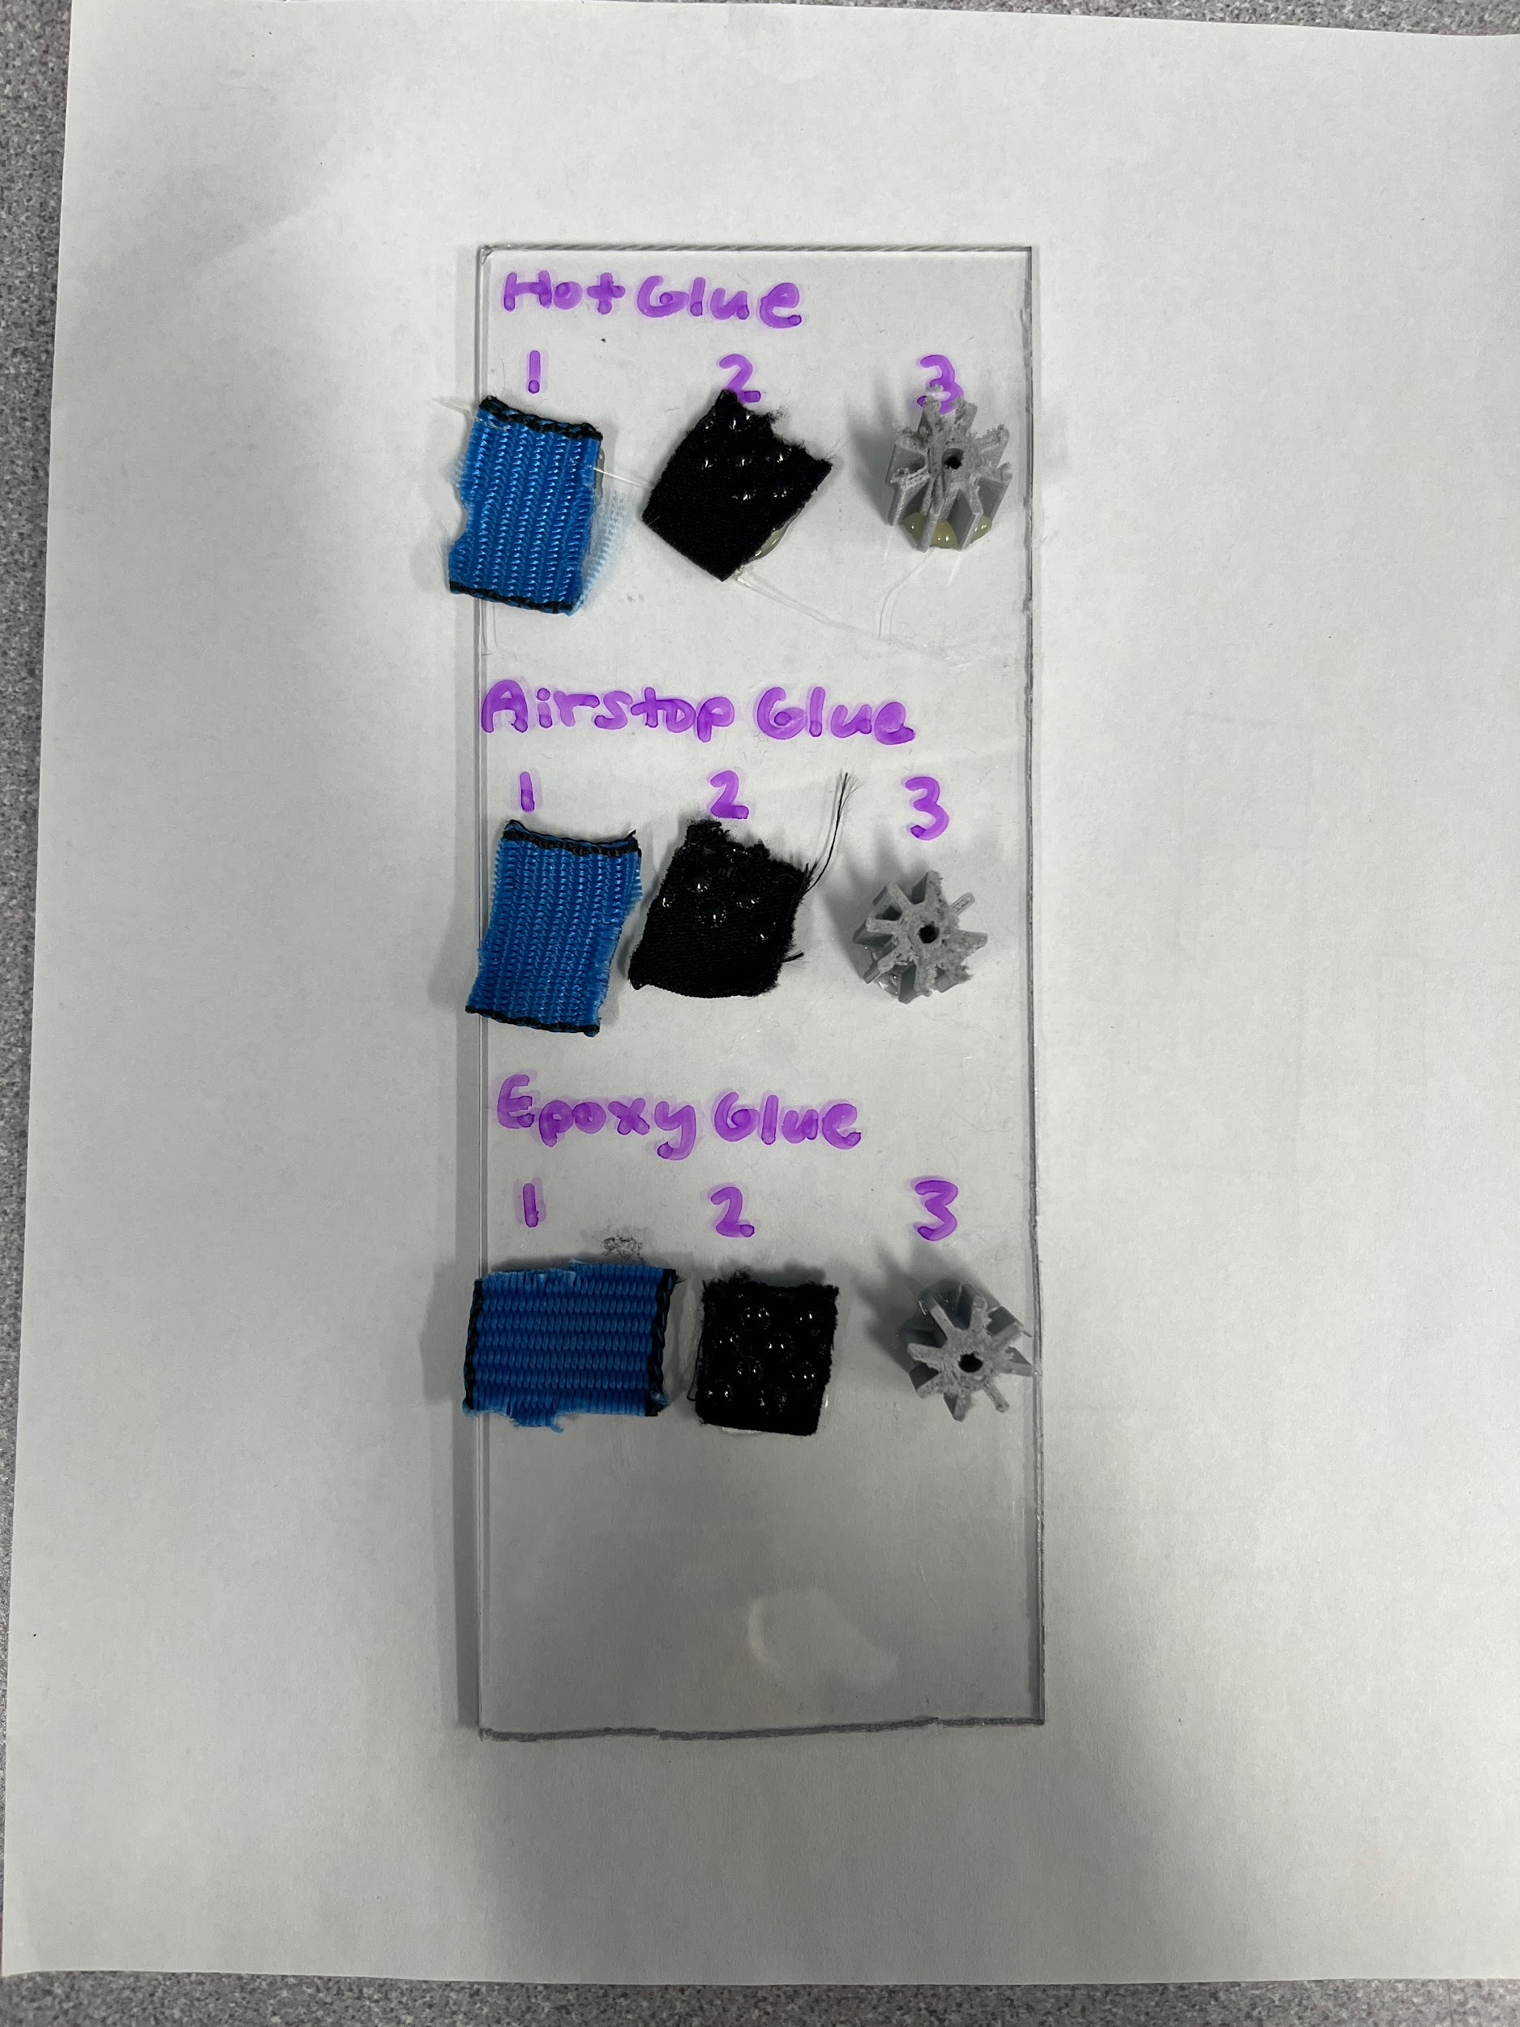

**Figure 5.13: Glue-to-material test**

After 24 hours, the glue was tested to determine the strength of each type of glue on each type of material. Tension was applied to test the strength by pulling each material away from the baseboard. Each material to glue combination was given a score on the durability of the glue on a scale of one to five. Respective scores were given to the glue with the materials: one for very secure, two for fairly secure, three for neutral, four for not secure, and five for not very secure. The results from the glue test can be seen in Table 5.1.

**Table 5.1: Glue-to-material scorings.**

| MATERIAL | GLUE TYPE | | |
| --- | --- | --- | --- |
| Hot | AirStop | Gorilla Epoxy |
| Control Board | 3 | 2 | 1 |
| Strap | 1 | 5 | 4 |
| Handle | 1 | 4 | 5 |

After the observation of the durability of the glue to the material and polycarbonate baseboard, it was concluded that the control board should be secured with the Gorilla Epoxy glue, and the strap and handle should be secured with hot glue.

### 5.2.11 Testing Model: Infant Head

To fully test the functionality of the final product a model infant head was to be made. Since our project focused on infants between the ages of 0 months to 6 months old, we have gathered information to model the head of an infant who is 0 months, 6 months, and an average of 0 to 6 months old. Because infant growth is not linear, we decided to use an average between 0 and 6 months, instead of the size of a 3 month old, to better represent the size range between these ages. For facilitated testing, the infants were labeled as follows:

* Infant 1: head size of 0 months old
* Infant 2: average head size of 0 and 6 month old
* Infant 3: head size of 6 months old

Information pertaining to infant heads were adapted from the Center for Disease Control and Prevention (33). The average values of male and female infants at the 50th percentile were taken to gather average sizes and to simplify the production of the head models. Table 5.2 below exhibits the calculations to obtain the average head circumference of our infants of interest.

**Table 5.2: Infant Head Circumference (cm) Calculation.**

|  | INFANT 1 | INFANT 2 | INFANT 3 |
| --- | --- | --- | --- |
| MALE | 35.81367 |  | 43.720495 |
| FEMALE | 34.71156 |  | 42.396845 |
| AVERAGE | 35.262615 | 39.1606425* | 43.05867 |

*Average from 0 month and 6 month old.

To model the mass of the infants, the following assumptions were to be made:

* The head of the infant is a sphere and thus it follows the same formulas of a sphere.
  + $c=2πr$ for the circumference
  + $v_{sphere}=\frac{4}{3}πr^{3}$ for the volume.
* The density of a human head is consistent among the lifespan of a human.

Using the spherical assumption, the circumference of an average adult head was found to be 55 cm (34), in which the radius was derived to be 8.75 cm from $r=\frac{c}{2π}=\frac{55cm}{2π}$. The volume of the head was calculated to be $2809.55 cm^{2}$, from $v_{sphere}=\frac{4}{3}π{(8.75cm)}^{3}$.

The density of a human head was calculated by dividing the average mass of an adult head, 3.65 kg (34), by the volume. Thus, the density of an adult head was calculated to be $1.30 g/cm^{2}$. The constant density assumption was made due to the lack of information available on the mass of an infant head, specifically within 0 and 6 months. Therefore, it was assumed that the density of Infant 1, Infant 2, and Infant 3 were equivalent to calculate the mass. Table 5.3 contains the calculated densities of the model heads.

**Table 5.3: Infant Head Model Size Calculations.**

|  | AVERAGE ADULT* | INFANT 1 | INFANT 2 | INFANT 3 |
| --- | --- | --- | --- | --- |
| CIRCUMFERENCE1 (cm) | 55 | 35.26 | 39.16 | 43.06 |
| RADIUS (cm)2 | 6.85 | 5.61 | 6.85 | 6.23 |
| MASS3 (g) | 3650 | 961.94 | 1751.41 | 1356.67 |
| VOLUME4 | 2809.55 | 740.44 | 1348.13 | 1014.14 |
| DENSITY5 | 1.30 | 1.30 | 1.30 | 1.30 |

* Given circumference and mass of the AVERAGE ADULT, all other values were calculated using the assumptions

1 Extracted from Table 5.2

2 Followed the following formula: ; where

3 Followed the following formula: ; where

4 Followed the following formula: ; where

5 Followed the following formula: $d=\frac{m}{v}$; where $d=density, m=mass, v=volume$

After calculating the density and volumes of the human head, it was believed that the most efficient method of creating the model heads is to fill the head with a mass of a material of a similar density. Therefore it was decided that play sand would be used as it has a density of $1.52 g/cm^{3}$ (35), similar to that of the calculated density of a human head. An elastic balloon was also decided to model the round shape of the head, and its elastic material allows the flexibility for different size heads for the three infant models. To fill the head, the specified mass of sand was measured and then placed in the balloon with the facilitation of a funnel. Figure 5.11 displays the three infant model heads created.

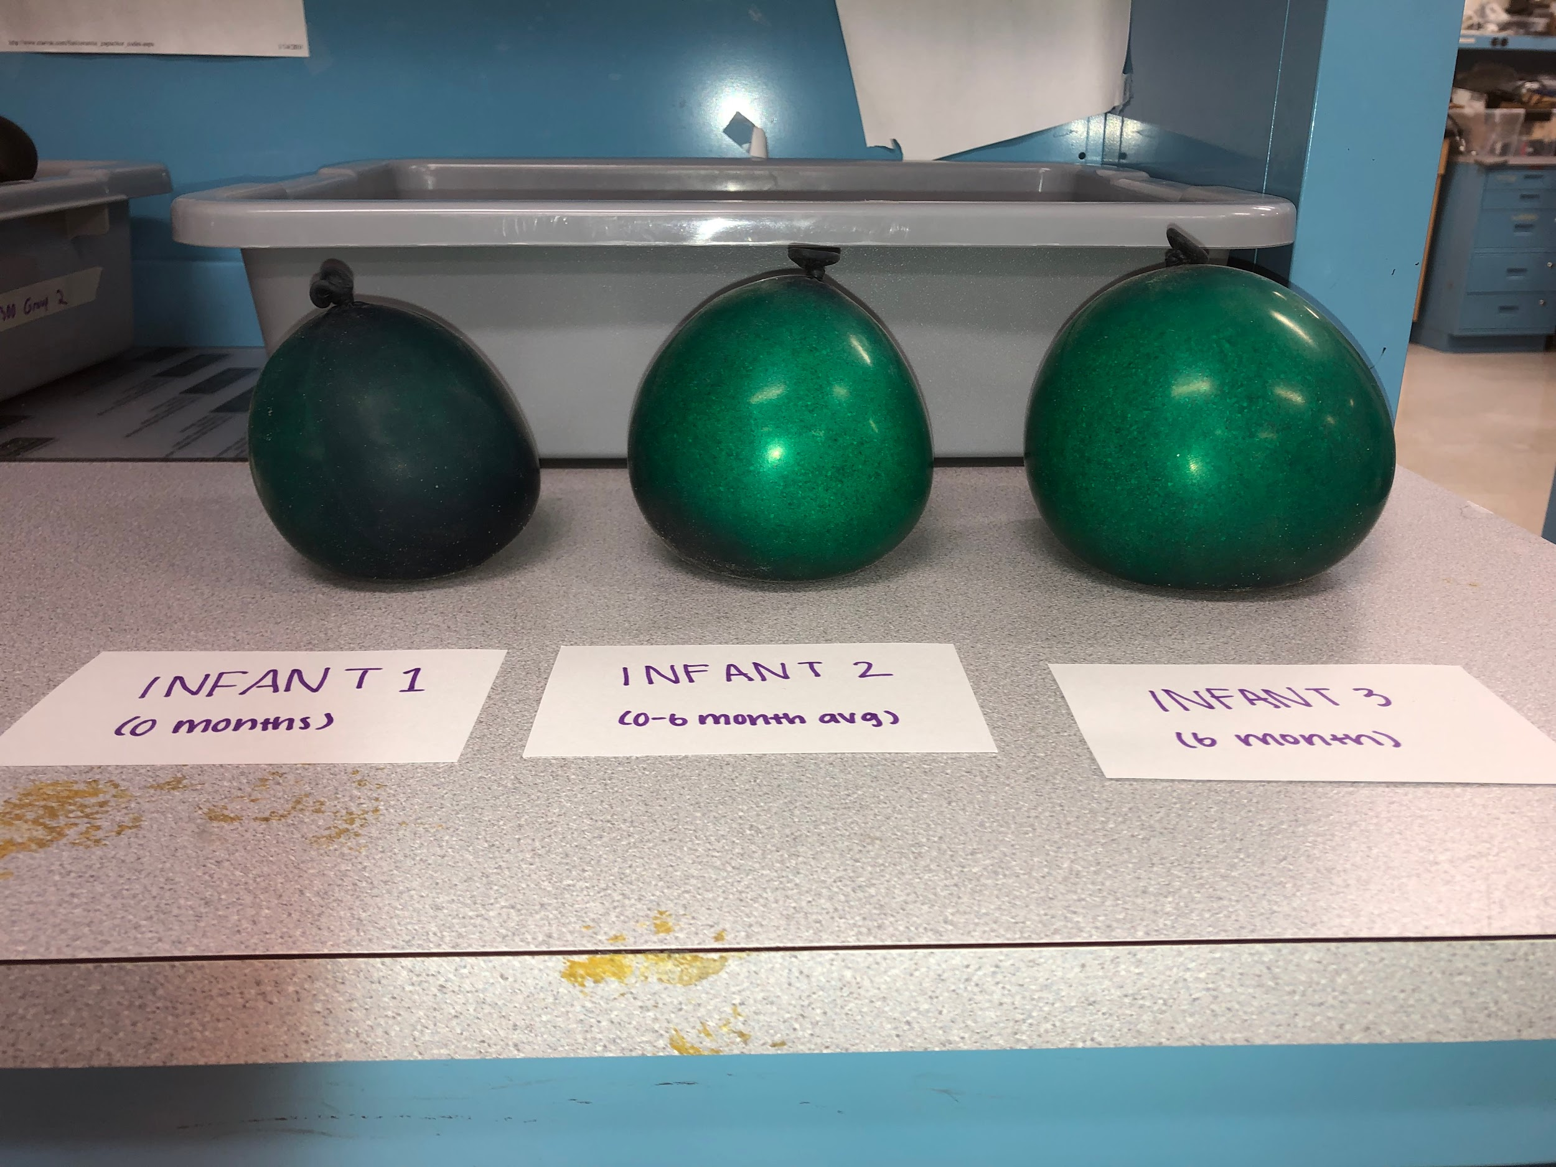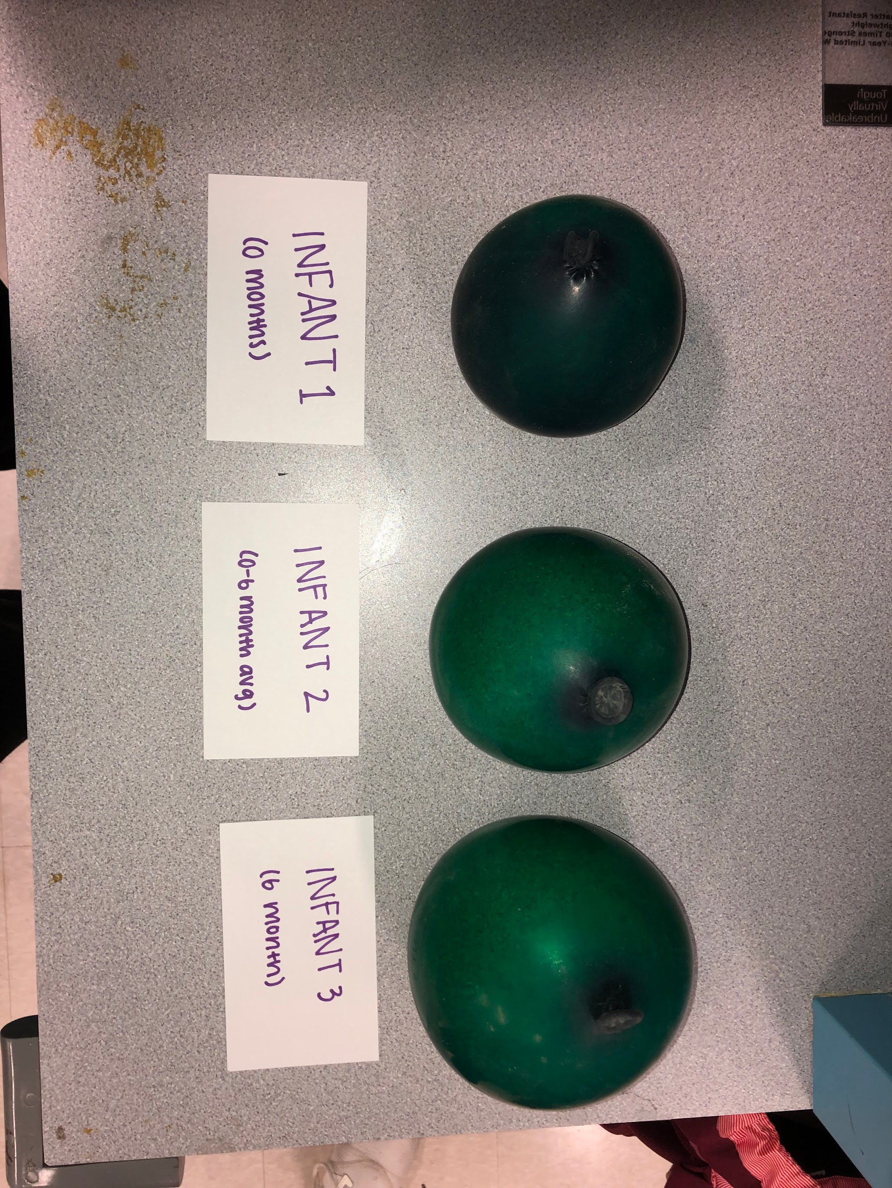

**Figure 5.14: Model infant heads side-view (left) and top-view (right)**

The neck of the infant was recreated by attaching the balloon to a PVC pipe. The main purpose of modeling the neck was to provide stability for the head during test rotations. Figure 5.12 shows the fully assembled infant head.

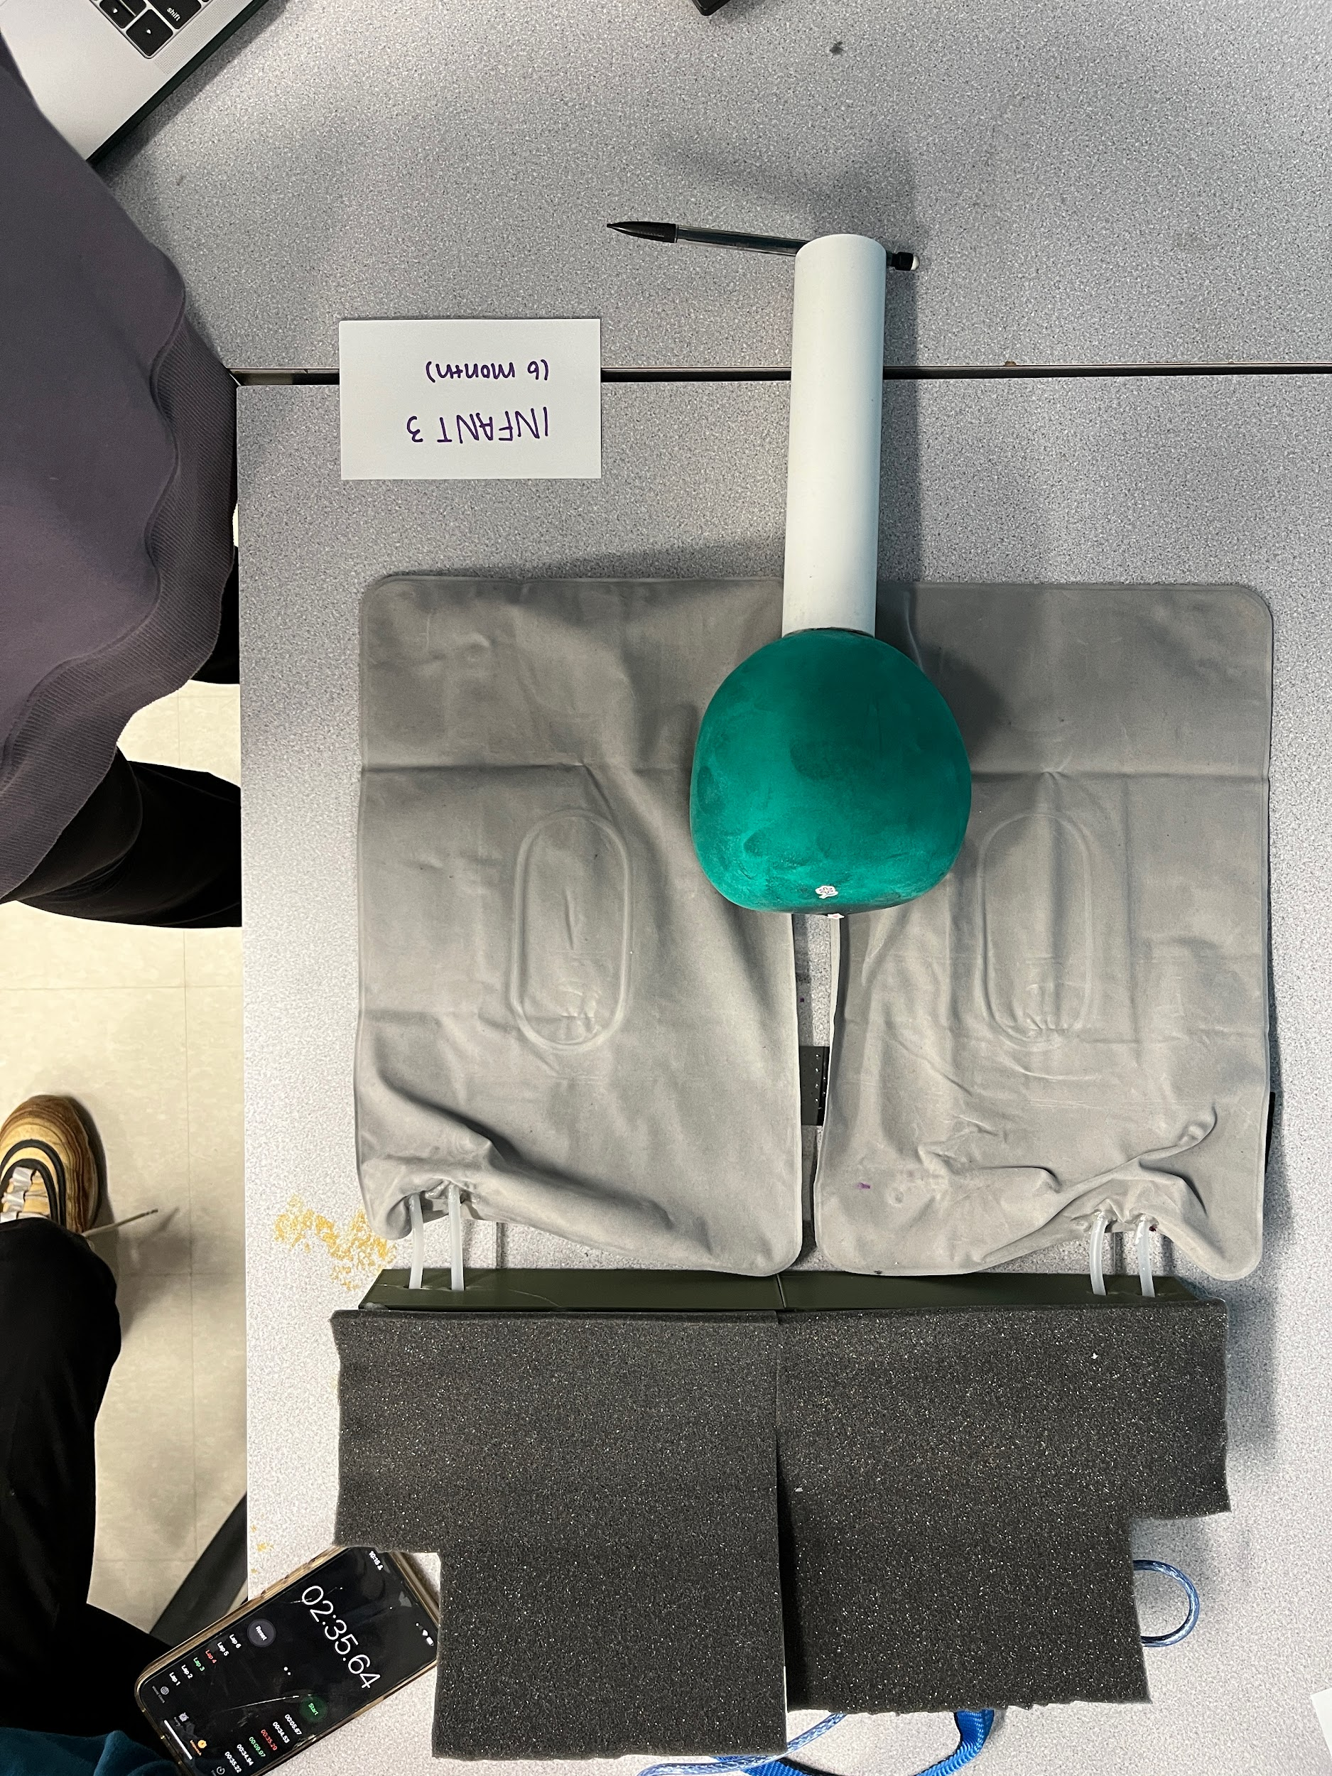

**Figure 5.15: Fully assembled infant head**

### 5.2.12 Cost Analysis

Given the materials covered in Chapter 5.2, a cost analysis was conducted to determine the total production cost of the device. Some of the materials were found in the lab scrap box, however the majority of the items were purchased. Table 5.4 breaks down the cost to produce our device.

**Table 5.4: Teeter-Tot Final Cost**

| **PART NAME** | **PRICE PER UNIT** | **UNITS USED** | **SUBTOTAL** |
| --- | --- | --- | --- |
| Air Pad | 1.79 | 2 | 3.58 |
| Air Pump | 8.99 | 4 | 35.96 |
| Pump Tube | 2.50 | 2 | 5.00 |
| Airtight Sealant | 9.06 | 1 | 9.06 |
| Hot Glue | 4.88 | 1 | 4.88 |
| Epoxy Glue* | 7.50 | 1 | 7.50 |
| Handle* | 0.25 | 1 | 0.25 |
| Strap* | 0.50 | 1 | 0.50 |
| Cover* | 0.50 | 1 | 0.50 |
| Device Baseboard* | 2.00 | 1 | 2.00 |
| Soundproof Foam | 14.95 | 0.167 | 2.49 |
| Filament [for control board] | 24.99 | 0.2 | 5.00 |
| On/Off Switch | 5.50 | 1 | 5.50 |
| Relay Board | 7.99 | 1 | 7.99 |
| Arduino Uno* | 28.00 | 1 | 28.00 |
| Bread board* | 4.00 | 1 | 4.00 |
| Wires* | 7 | 0.33 | 2.33 |
|  |  | **TOTAL** | **124.54** |

*these parts were found in the lab scrap box, so added no additional cost to our prototype development

The final cost of the Teeter-Tot was totaled to be $124.54. However, the production cost of the device was to be $79.46, as some material used in the production of the device was found in the lab, free to use.

Compared to other devices on the market that have the same purpose (discussed in Chapter 2.4), our device’s concept is unique in that the approach at which it can prevent flat head syndrome is not comparable to current products. Thus, it is difficult to compare the cost of the Teeter-Tot with the cost of a pre-existing device, such as the Perfect Noggin. Although the Perfect Noggin retails for $150, we are unsure of its production cost, as this cost might be significantly lower. Since the cost of the Teeter-Tot was totaled to be $124.54, we can say the costs of the Teeter-Tot and Perfect Noggin are relatively the same, since the concept is different.

## 5.3 Mechanical Components

The mechanical components of our design consisted of the modeling and printing of our control board as well as the air transfer function from the control board to the inflatable cushions. The control board of the device was modeled using Creo. The part was designed to hold all of the electrical components for the device as organized as possible. Figure _. displays the layout and dimensioning of the control panel.

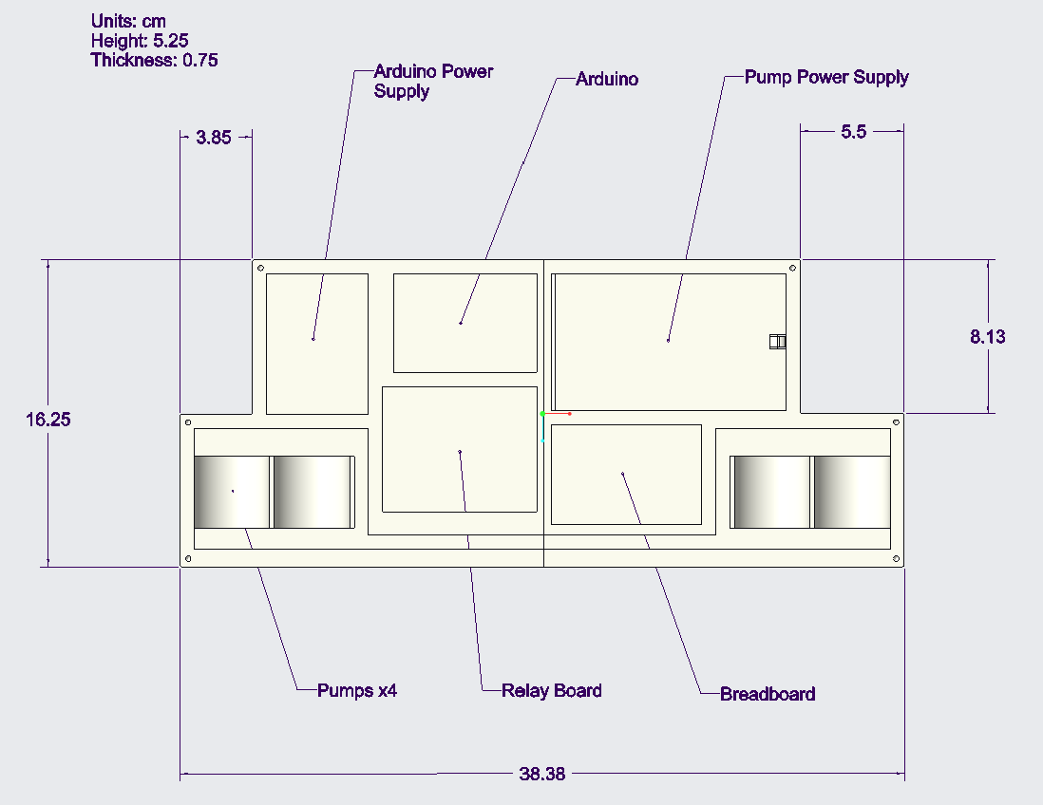

**Figure 5.16: CAD Model of Control Board**

Once the 3D model was generated, the model was then 3D printed using PLA filament. The general printing process took roughly 48 hours of printing due to the printer used.

The next feature was the transportation of air from the pumps to the inflatable cushions. The control board contained holes to allow for the plastic tubes to cross over from the interior part of the board to the exterior. These tubes were then connected to pumps inside as well as additional tubes on the other side of the pump to allow for external air to be taken in and released. Finally, four incisions, roughly the same size of the tubes, were made in the inflatable cushion. The tubes were inserted into the slits and glued using the airstop glue. This allowed for a controlled and secured transport of air from the external air, to the pumps, to the inflatable cushions, and then reversed.

## 5.4 Electrical Components

The electrical components of our design consisted of the Arduino, relay board, power supplies and pumps that were mentioned earlier. In order to get everything to work in tandem with each other, a circuit was created. Code in Arduino IDE was used to set the cycle of the pumps and activate the buttons.

### 5.4.1 Circuit

The circuit used for this prototype was simple. Relay activation was wired to pins 10-13 on the Arduino. The ground and 5V pin were also wired to the relay board. The positive end of the 12V battery was wired to all four channels of the relay board as well. The positive end of the air pumps were wired to the “normally closed” pin of each relay channel as well. Finally, the negative end of each pump was wired to the negative end of the 12V battery pack.

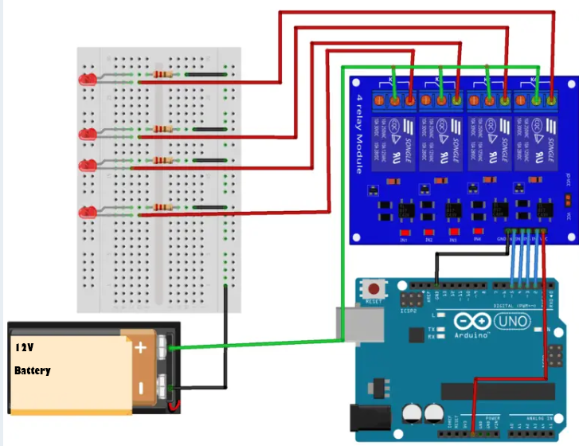

**Figure 5.17: Sample diagram of circuit (MYTECTUTOR)**

For the buttons, the wiring was done on a small breadboard that was connected to the arduino. This was a simple circuit that connected each button to one pin from A3-A5. Each button was also wired to ground and coded to have an internal resistor to maintain a HIGH setting till the button is pressed.

### 5.4.2 Arduino Code

The code begins by defining all variables. After that, a function is defined that will check the state of the buttons to see if any happened to be pressed.

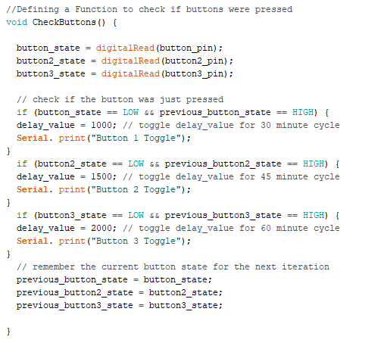

**Figure 5.18: Defining a Check Buttons Function**

After defining that function, pins are defined as either input or output in void setup(). Button pins are a special case. Button pins are defined as “INPUT_PULLUP”. This means that they are set as an input with an internal pull up resistor of between 20k-50k ohms. This keeps the button pins setting at “HIGH” on default, and allows for a simpler wiring configuration. Next, in void loop(), the pump cycle is coded.

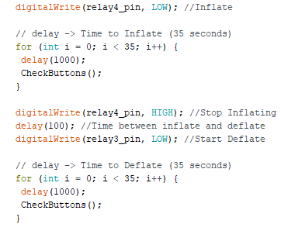

**Figure 5.19: Beginning of Loop that Initially Inflates and Deflates Pad**

At the beginning of the loop function, the first pad is inflated and deflated to turn the baby's head. Through testing, it was found the pumps take about 35 seconds to fully inflate and deflate the pad. A delay of about 1 millisecond is set in between the inflate and deflate. During inflate and deflate, the CheckButtons function that was defined earlier is run. This makes sure that buttons pressed during inflation or deflation will still affect cycle time.

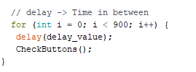

**Figure 5.20: Code for Time in Between Each Inflation Cycle**

Above is the code for the time period in between each inflation. The default cycle is set to 45 minutes, which is a delay_time variable of 1.5 second. This means that the time in between each inflate-deflate will be 22.5 minutes. During this period, if a button is pressed, it will change the time in-between cycles from the time of the push. If the cycle is halfway through its 22.5 min wait time, and you press the 75 minute button, total time would not reach 37.5 minutes. It would be somewhere in between 22.5 and 37.5, closer to around 30 minutes. This code also means that the button must be held for at least 2.5 seconds to ensure that it is read. The rest of the code is a repeat of the above code. Full code can be found in Appendix A.

# 6.0 Testing

To ensure the functional blocks (Chapter 4.1) and technical specifications (Chapter 4.2) were met, the following tests were conducted:

* Cycle Duration: Each cycle transition takes longer than 15 seconds.
* Size Compatibility: Device will fit a range of infants ages 0 to 6 months.
* Portability: The device can be transported or folded up and packed.
* Sound Test: The active device does not exceed 60 dB of sound.
* Rotation Angle: An automated system that will gradually change the head position of an infant, without rotating the head more than 90 degrees.
* User Assembly: A picture guide is provided for easy set-up with less than 5 steps.
* Location Versatility: The device can be used on any infant-sized sleeping location.
* Power Duration: The electronics can be fully powered through battery usage.

The tests were ultimately passed or failed. The failure of a test does not mean the device is not valid, as there are improvements to the device that can enhance the product’s features. Chapter 7 goes more into depth about the recommendations and improvements that could be made to the final design.

## 6.1 Cycle Duration

The purpose of this test is to ensure that the duration of each cycle transition does not take any less than 15 seconds, as any movement that is quicker than 15 seconds may cause harm to the infant. The following procedure was conducted for this test:

1. Setup the product.
2. Start and record the timer when the pump in the product is initiated.
3. Determine if the inflatable section of the product inflates fully before or after 15 seconds. If the inflation stops before 15 seconds, adjust the inflation timer and return to Step 1. If the inflation continues after 15 seconds, the test is successful.
4. Repeat steps 1-3 for each stage of the inflation/deflation process for the product.

When the device is on, the time of rotation from one position to another is intended to not take any less than 15 seconds. Thus, each inflation and deflation time was recorded in Table 6.1.

**Table 6.1: Duration of Position Transition of Infant Head**

| TRIAL | INFLATION | | DEFLATION | |
| --- | --- | --- | --- | --- |
| LEFT PAD | RIGHT PAD | LEFT PAD | RIGHT PAD |
| 1 | 34.76 | 34.24 | 35.01 | 34.81 |
| 2 | 35.17 | 34.14 | 34.65 | 35.36 |
| 3 | 35.29 | 35.22 | 34.53 | 34.94 |
| AVG | 35.07 | 34.53 | 34.73 | 35.03 |
| STD | 0.28 | 0.60 | 0.25 | 0.29 |

With a sample size of 3, the times of the inflation and deflation on the left and right pads were measured. The average of the inflation and deflation times of the left and right pads were found to be greater than 15 seconds, in between 34 and 35 seconds, meaning that this test passed. Since the time of inflation and deflation were greater than 15 seconds, we are positive that there is no extreme force exerted on the infant that would make it unsafe and uncomfortable for the infant while using this device.

## 6.2 Size Compatibility

To ensure that the device could accommodate infants of varying sizes we performed this test. In order to conduct this test we used the model infant heads that we created, placed them on the device, and then rated how each fit on a scale of 1-5. 1 was a “very good fit” and 5 was a “very bad fit”. We recorded the evaluations in table 6.2.

**Table 6.2: Fit of Model Infant Heads on Device**

|  | Evaluation of Fit |
| --- | --- |
| INFANT 1 | 2 |
| INFANT 2 | 2 |
| INFANT 3 | 1 |

Based on these results, our device passed this test. It successfully accommodated the model heads of infants ranging from 0 to 6 months.

## 6.3 Portability

In this test we evaluated if the device was portable. We assessed whether the device could fold up or included a handle. Our final device could not fold up, so it failed that portion of the test, but it did include a carrying handle, so it passed that portion.

## 6.4 Sound Test

In order for this device to be comfortable for the infants while sleeping, the noise level needs to be low. Therefore, the purpose of conducting this test is to record and determine if the noise level of the device is lower than 60 decibels. This test will require a decibel meter. The following procedure was conducted for this test:

1. Set up the device.
2. Turn the decibel meter and use the default setting. Record the noise level every two seconds.
3. Record the noise level for the inflation and deflation cycles on the left part of the device.
4. Record the noise level for the inflation and deflation cycles on the right part of the device.
5. Take the average noise volume per cycle. If the sound volume is 60 dB or lower, the test passes. If the volume is over 60 dB, the test fails.

In result, our team obtained the following data:

**Table 6.3: Volume of both inflation and deflation**

|  | CYCLE | | | |
| --- | --- | --- | --- | --- |
| LEFT | | RIGHT | |
| INFLATION | DEFLATION | INFLATION | DEFLATION |
| Average Sound Volume (dB) | 74.2 | 59.1 | 72.0 | 68.7 |
| Standard Deviation Sound Volume (dB) | 3.8 | 0.6 | 1.1 | 0.5 |

Based on our results, only one of the pumps produced a noise level below 60 dB. Therefore, 75% of the cycles failed the test, proving the noise level is not comfortable for the infant.

## 6.5 Rotation Angle

The purpose of this test is to ensure that the inflation and deflation of the air pads did not enforce excessive rotation of the head, where the angle of rotation was greater than 90 degrees. This test will address the objectives of the prevention of a stationary head position, safety, and comfort. The following procedure was conducted for this test:

1. Place the first size of the infant model on the product.
2. Place a marker at the center of the head. Place another marker at the top of the head.
3. Take a picture while the infant model is lying down, where the markers are visible in the image.
4. Begin the inflation of the first side of the device.
5. Once the first side of the air pad is fully inflated, another image should be taken where the markers are visible.
6. After the same side is deflated, another image should be taken where the markers are visible.
7. Repeat Steps 2-6 with the 2 other sizes of infant heads
8. Using an image analyzing software with a coordinate system, record the points where the markers were.

The images at each maximum point of rotation were taken of each infant. Figure 6.1 below exhibits the images that were taken.

| Supine position | Left pad inflated | Right pad inflated |
| --- | --- | --- |

**Figure 6.1: Infant 1 images taken for rotation angle analysis.**

The data was analyzed using Adobe’s Photoshop, where the coordinates for each marker were identified in each image. Table 6.4 exhibits the identified coordinates for each infant model. P0  indicates the point of reference in which it was the marker at the center of the head, Pi indicates the start position of the marker which is usually at the top of the head, and Pf indicates the final position of the marker. Prior to recording the raw coordinate values, the coordinates were normalized by setting the origin of the coordinate system to be on the center marker, P0.

**Table 6.4: Normalized coordinate values for rotation angle test**

|  | INFANT 1 | | | | INFANT 2 | | | | INFANT 3 | | | |
| --- | --- | --- | --- | --- | --- | --- | --- | --- | --- | --- | --- | --- |
| RIGHT | | LEFT | | RIGHT | | LEFT | | RIGHT | | LEFT | |
| x | y | x | y | x | y | x | y | x | y | x | y |
| P0 | 0 | 0 | 0 | 0 | 0 | 0 | 0 | 0 | 0 | 0 | 0 | 0 |
| Pi | 0 | 1240 | 82.38 | 1371 | -71.73 | 1239 | -74.98 | 1295 | 110 | 1302 | 110 | 1302 |
| Pf | 687 | 1032 | -936 | 1005 | 767 | 976 | -946 | 888 | 685 | 1112 | -793 | 1039 |

To determine the angle of rotation on each infant and each direction from the coordinates given, a triangle can be formed. Thus, the distances between each point, P0, Pi, and Pf, can be found and the angle of rotation, at the angle at the point of origin, can be calculated. Figure 6.2 below exhibits the visualization of the calculations, where $α$ indicates the angle of rotation.

# 

**Figure 6.2: Visualization of angle of rotation calculation.**

The distance between each point was calculated and exhibited in Table 6.5, using the distance between two points formula:

$d=\sqrt{(x_{2}-x_{1})^{2}+(y_{2}-y_{1})^{2}}$

where $d=distance$, $x_{2}=x coordinate of point 2$, $x_{1}=x coordinate of point 1$, $y_{2}=y coordinate of point 2$, $y_{1}=y coordinate of point 1$

**Table 6.5: Calculation between two points**

|  | INFANT 1 | | | | INFANT 2 | | | | INFANT 3 | | | |
| --- | --- | --- | --- | --- | --- | --- | --- | --- | --- | --- | --- | --- |
| RIGHT | | LEFT | | RIGHT | | LEFT | | RIGHT | | LEFT | |
| $P_{i}-P_{0}$ | 1240 | | 1373 | | 1241 | | 1297 | | 1307 | | 1307 | |
| $P_{f}-P_{0}$ | 1240 | | 1273 | | 1241 | | 1297 | | 1307 | | 1307 | |
| $P_{f}-P_{i}$ | 718 | | 1082 | | 879 | | 962 | | 605 | | 940 | |

After calculating the distance between each point, the angle of rotation could be calculated using the law of cosines:

$c^{2}=a^{2}+b^{2}-2ab⋅cosα$

where $c=P_{f}-P_{i}$, $b=P_{i}-P_{0}$, and $a=P_{f}-P_{0}$

When rearranged, the angle, $α$, can be calculated, in which the calculated angles can be seen in Table 6.6:

$α=cos^{-1}(\frac{c^{2}-a^{2}-b^{2}}{-2ab})$

**Table 6.6: Calculation of angle of rotation**

|  | INFANT 1 | | INFANT 2 | | INFANT 3 | |
| --- | --- | --- | --- | --- | --- | --- |
|  | RIGHT | LEFT | RIGHT | LEFT | RIGHT | LEFT |
| Angle of Rotation (degrees) | 33.65 | 46.40 | 41.48 | 43.50 | 26.79 | 42.18 |

It was seen that all the angles of rotations were less than 90 degrees, in which it deemed the test as passing. The validation of this test suggests that the device will be safe and comfortable for the infant because there are not any harmful forces applied on the infant head.

## 6.6 User Assembly

One of our team’s objectives was to create a user friendly product. The test conducted to check for this was a user assemble test. For this test, a user with no prior experience using the product was asked to install the product. Afterwards, they were asked to rate how easy or hard it was on a scale from 1-5. The subjects of this test were given a user assembly guide in order to assist them with installation. The user installation guide was kept to concise wording, and pictures to convey its message. Three different users were given this test, to which two of them said it was easy to install with a ⅖ rating. The third user said the product was difficult to install with a ⅘ rating.

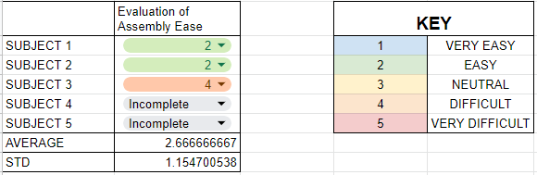

**Figure 6.3: User assembly test results**

This test was inconclusive. In further testing there should be a slightly more detailed user assembly guide made, and less switches and buttons needed to turn the product on.

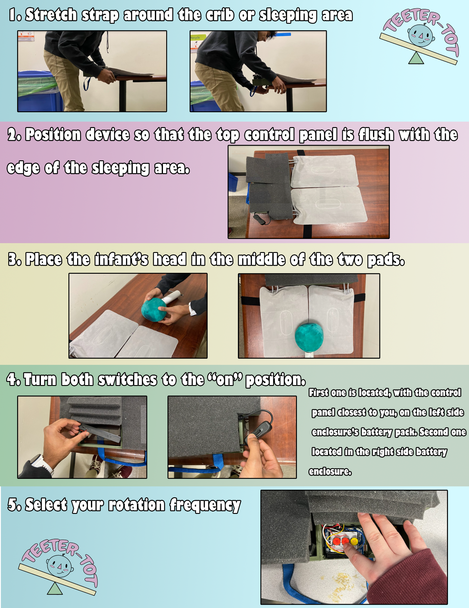

**Figure 6.4: Teeter-Tot User Assembly Guide**

## 6.7 Location Versatility

Another one of our team’s objectives was to make the device portable and allow for the ability to use anywhere the infant can safely rest. In order to ensure the portability of our device, a test was created to determine if the device can be used in several locations. The following procedure was conducted for this test:

1. Install the device on a location that is similar to an infant sleeping location.
2. Measure the width of the chosen location.
3. Wrap the strap on the bottom of the device around the chosen location.
4. Evaluate the fit of the device on a scale of 1-5
   1. 1 = very good fit
   2. 2 = good fit
   3. 3 = neutral
   4. 4 = bad fit
   5. 5 = very bad fit
5. Repeat on different shaped and sized locations

The data collected was based on the locations we used. Locations tested on should be considered safe enough to rest an infant on.

**Table 6.7: Location Safety for Device**

| LOCATION NUMBER (#) | LOCATION DESCRIPTION | LOCATION WIDTH (cm) | RANK (1-5) |
| --- | --- | --- | --- |
| 1 | Water Table Outside of GH007 | 58.5 | 1 |
| 2 | Goddard Hall Table Floor 1 | 72.5 | 5 |
| 3 | Goddard Hall Table Floor 2 | 72.5 | 5 |

Based on our results, two locations failed due to the width of the location. Therefore, the device does not have the ability to be secured on surfaces with a width of 72.5 cm but is safe on surfaces above 58.5 cm.

## 6.8 Power Duration

The power duration test was intended to check if the product could be switched on for 6 hours during the 45 minute cycle. This test was not fully performed at any point because the 9 volt battery that was used could not activate for more than around 30 minutes.

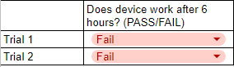

**Figure 6.5: Power Duration Test Results**

This is an understandable result due to the large amounts of inputs being utilized by the arduino at once. The 5V pin, as well as 4 digital pins are used for just the relay. Another 3 input pins and 3 output pins are then used for the buttons. On top of that, buttons are being checked by the Arduino every 1-2 seconds. Because of the large amount of pins being utilized, a larger power supply is recommended.

# 

# 7.0 Discussion

## 7.1 Regulations and Standards

We considered two regulations for our device, infant safety and labeling requirements. Infant safety pertains to electrical, physical, and functional safety. The labeling requirements that we considered are general device labeling, the use of symbols, our unique device identification, and the labeling of general electronic products. Through the consideration of these regulations, we made sure that our device would not harm the infant user, with instructions and warnings that are clear to the adult consumer.

### 7.1.1 Infant Safety

The first regulation that we considered was infant safety. We considered electrical, physical, and functional safety. For electrical safety, we designed the device to have power sources that were fully covered to prevent the infant from electrocuting themself or getting tangled in wires. Regarding physical safety, we designed the device so that the shape and materials used would be safe for an infant to use and be around. The baseboard was made from a material that does not shatter and is very hard to break. For the inflatable pads we used air mattress material so that the infant would not be able to easily puncture them. The cover material used was elastic so that there would be no excess material when the pads were deflated. For functional safety, we evaluated the movement of the infant that the device would cause in the angle of rotation test (section 6.5).

### 7.1.2 Labeling Requirements

The second regulation that we considered was labeling requirements. We considered general device labeling, the use of symbols, our unique device identification, as well as the labeling of general electronic products. For general device labeling and the use of symbols we decided to omit the use of any symbols and use numbers to label the different frequency option buttons. Instead of labeling them 1, 2, and 3, we put the frequency of rotation on each button (45, 60, and 75). Doing this makes it clear to the consumer what each button does. We did not use any other symbols or labels in the device. Our device is easily identifiable through the logo we made. In the logo we featured an infant on a seesaw (also known as a teeter totter), which represents how our device inflates to rotate the infant’s head. Since our device is electronic we had to also consider general electronic product labeling. Our device would come with a warning packet that identifies it as containing electrical components. This would allow the consumer to use it properly without damaging it or hurting themselves.

## 7.2 Ethics

Through the development of the Teeter-Tot, decisions were made with ethical considerations for the feasibility of the product on the consumer and users.

### 7.2.1 Clinical Testing

The main ethical issue that will be encountered during the project development of the Teeter-Tot is in the clinical testing phase. To ensure that our device is truly functional on infants, we will have to test the product on our targeted infants who are between the ages of 0 and 6 months. Typically when clinical trials are conducted on human subjects, the subject’s consent is required because it allows the subject to have the informed choice of participating in the study, and that they understand the benefits and risks of their participation. Since our human subjects would be infants under 6 months, they are unable to clearly communicate whether or not they accept their participation in the study. Thus, we are not sure if it is truly ethical if infants are used in these clinical trials. However, this issue may be partially solved if the informed consent was received by the caretakers of the infants, as the caretakers are aware of the consequences of the risks that could occur to the infant if they allow the infant to participate.

### 7.2.2 Caretaker Negligence

Another ethical issue that arises from the Teeter-Tot is the after establishment of the device. Due to the natural convenience of the device where the infant may be left unattended for a few hours, the caretaker may become reliant on the device. As the infant is in one of the most important developmental phases in their life between the ages of 0 and 6 months, attention from the parent and caretakers are important as it provides security to the infant. Since an aspect of the device is to allow the caretaker to be relieved of stress because they do not need to consistently rotate the infant’s head position every few hours, or monitoring that the infant’s head position is always moved, the device may indirectly promote caretaker negligence. Caretaker negligence could result in a negative impact on the infant’s psychological development. Although if the device suggests that the infant should not be left unattended for more than six hours while the product is in use, the possibility of caretaker negligence may be decreased.

# 

# 8.0 Conclusion

Based on the results of our testing, our device passed five out eight tests. This means our design performed well, but needs some more improvement. The following section includes potential future modifications to improve on the device quality as well as other potential areas of focus for this type of technology.

## 8.1 Recommendations and Future Modifications

The device prototype our team had produced achieved objectives that are higher priority objectives while not fully completing lower priority objectives. Specifically, our device has the ability to safely rotate the heads of different size infants. However, the device is not comfortable, fully portable, or consistently automated. Potential improvements include altering the materials used and size of the components.

Different, higher quality materials could improve the comfort and automation. Smaller, more energy efficient pumps and microcontrollers would reduce the battery usage as well as the volume produced by the device. Unfortunately, due to our team’s budget and time, higher quality components were unable to be implemented. However, these suggested improvements can increase the quality and duration of the device. The change in materials also has an impact on the size of the device. A more efficient and compact device can improve upon the comfort and portability of the device. Smaller pumps, wiring, and power sources can allow the control panel to be smaller in size, reducing the overall size of the device. This also makes the device simple and easy to transport and use in smaller more compact areas.

Ultimately, these smaller changes to the device can make a large impact on other features but can impact others. For example, if the device includes higher quality materials, the overall price of the device would most likely increase, making the device less appealing. Therefore, these features need to be balanced to make the most optimal device for all involved.

## 8.2 Additional Applications

Our team’s intention was solely to make an impact on the prevention of positional plagiocephaly. However, during the process of producing our device, other potential areas of focus were thought of that could benefit from this type of device. Specifically, focusing on people who are consistently lying on their backs through automated assistance in rotating. Examples of this include people in comas, of old age, or in recovery who physically do not have the ability to adjust the position of the body could significantly benefit from a device similar to our team’s. With further improvement and iterations of our team’s device, a complete and marketable product could result from this.

## 

# 9.0 References

[1]

“Cranial helmet”, [Online]. Available: https://deccanorthopro.com/wp-content/uploads/2018/10/img4.jpg

[2]

T. Siddiquee, “Sand Unit Weight or Specific Weight - Calculation”, [Online]. Available: https://civiltoday.com/civil-engineering-materials/sand/360-unit-weight-of-sand#:~:text=Specific%20Weight%20or%20Unit%20weight%20of%20Sand&text=According%20to%20the%20US%20customary,foot%20%5Blb%2Fft%C2%B3%5D

[3]

L. A. van Vlimmeren, Y. van der Graaf, M. M. Boere-Boonekamp, M. P. L’Hoir, P. J. M. Helders, and R. H. H. Engelbert, “Risk Factors for Deformational Plagiocephaly at Birth and at 7 Weeks of Age: A Prospective Cohort Study,” *American Academy of Pediatrics*, vol. 119, no. 2, Feb. 2007, Accessed: Mar. 03, 2023. [Online]. Available: https://publications.aap.org//ExternalLoginResponse.ashx?elpId=3&redirecturlback=http://publications.aap.org/pediatrics/article-abstract/119/2/e408/70294/Risk-Factors-for-Deformational-Plagiocephaly-at?autologincheck=redirected&nfToken=00000000-0000-0000-0000-000000000000

[4]

B. L. Hutchison, L. A. D. Hutchison, J. M. D. Thompson, and E. A. Mitchell, “Plagiocephaly and Brachycephaly in the First Two Years of Life: A Prospective Cohort Study,” 2004, [Online]. Available: http://www.cranioform.de/fileadmin/user_upload/Media/Infothek/Interessante%20Artikel/Plagiocephaly_and_Brachycephaly-Hutchison.pdf

[5]

C. Cummings, “Positional Plagiocephaly,” *Canadian Paediatric Society, Community Paediatrics Committee*, vol. 16, no. 8, pp. 493–494, Oct. 2011, Accessed: Mar. 03, 2023. [Online]. Available: https://doi.org/10.1093/pch/16.8.493

[6]

“Anatomy of Newborn Skull,” *Stanford Medicine - Children’s Health*. https://www.stanfordchildrens.org/en/topic/default?id=anatomy-of-the-newborn-skull-90-P01840 (accessed Mar. 03, 2023).

[7]

“Plagiocephaly | Boston Children’s Hospital,” *Boston Children’s Museum*, 2023. https://www.childrenshospital.org/conditions/plagiocephaly (accessed Mar. 03, 2023).

[8]

B. Schiedel, “What you need to know about flat head syndrome—including how to treat it,” *Today’s Parent*, Oct. 11, 2018. https://www.todaysparent.com/baby/what-you-need-to-know-about-flat-head-syndrome-including-how-to-treat-it/ (accessed Mar. 03, 2023).

[9]

“Perfect Noggin,” *Boston Orthotics and Prosthetics*, 2006, [Online]. Available: https://www.bostonoandp.com/products/plagiocephaly/perfectnoggin/

[10]

C. Miles, “Guide | Physical Therapy Guide to Flat Head Syndrome: Plagiocephaly, Brachycephaly, and Dolichocephaly,” *Choose PT*, Jun. 16, 2022. https://www.choosept.com/guide/physical-therapy-guide-to-head-shape-flatness-in-infants-plagiocephaly (accessed Mar. 03, 2023).

[11]

“Shop | The Perfect Noggin,” *The PerfectNoggin*. https://www.theperfectnoggin.com/shop-1 (accessed Mar. 03, 2023).

[12]

“FDA Says Head-Shaping Pillows for Infants Can Be Dangerous,” *Healthline*, Nov. 09, 2022. https://www.healthline.com/health-news/fda-says-head-shaping-pillows-for-infants-can-be-dangerous-what-parents-should-know (accessed Mar. 03, 2023).

[13]

“Perfect Noggin Infant Head Shaping Mattress,” *The PerfectNoggin*. https://www.theperfectnoggin.com (accessed Mar. 03, 2023).

[14]

“Human head,” *Wikipedia*. Mar. 02, 2023. Accessed: Mar. 03, 2023. [Online]. Available: https://en.wikipedia.org/w/index.php?title=Human_head&oldid=1142514839

[15]

“Growth Charts - Data Table of Infant Head Circumference-for-age Charts,” Jan. 11, 2019. https://www.cdc.gov/growthcharts/html_charts/hcageinf.htm (accessed Mar. 03, 2023).

[16]

“Baby’s Head Shape: Should You Be Concerned?” https://www.nationwidechildrens.org/family-resources-education/700childrens/2016/12/babys-head-shape-should-you-be-concerned (accessed Mar. 03, 2023).

[17]

“Deformational Plagiocephaly--A Focus on - ProQuest.” https://www.proquest.com/docview/1867965867?accountid=29120&parentSessionId=rL5JFP6uofqbzfcYQ7NCD28JPejrn8g8sbEd7Gtemc0%3D&pq-origsite=primo&forcedol=true (accessed Mar. 03, 2023).

[18]

A. Leung, P. Watter, and J. Gavranich, “Characteristics of infants with positional abnormal head shapes and their physiotherapy service at an Australian community health facility,” pp. 83–92, 2014, doi: 10.2147/PHMT.S61989.

[19]

this link will open in a new window Link to external site, this link will open in a new window Link to external site, and this link will open in a new window Link to external site, “Active Cervical Range of Motion in Babies with Positional Plagiocephaly: Analytical Cross-Sectional Study,” p. 1146, 2021, doi: 10.3390/children8121146.

[20]

S. U. Sheu, M. K. Ethen, A. E. Scheuerle, and P. H. Langlois, “Investigation Into an Increase in Plagiocephaly in Texas From 1999 to 2007,” *Archives of Pediatrics & Adolescent Medicine*, vol. 165, no. 8, pp. 708–713, Aug. 2011, doi: 10.1001/archpediatrics.2011.42.

[21]

C. Di Rocco, G. Paternoster, M. Caldarelli, L. Massimi, and G. Tamburrini, “Anterior plagiocephaly: epidemiology, clinical findings,diagnosis, and classification. A review,” *Childs Nerv Syst*, vol. 28, no. 9, pp. 1413–1422, Sep. 2012, doi: 10.1007/s00381-012-1845-2.

[22]

“Flat head syndrome linked to motor, language and cognitive delays,” *ScienceDaily*. https://www.sciencedaily.com/releases/2017/01/170124111344.htm (accessed Mar. 03, 2023).

[23]

R. I. Miller and S. K. Clarren, “Long-term developmental outcomes in patients with deformational plagiocephaly,” *Pediatrics*, vol. 105, no. 2, p. E26, Feb. 2000, doi: 10.1542/peds.105.2.e26.

[24]

Y. K. Cloonan, B. Collett, M. L. Speltz, M. Anderka, and M. M. Werler, “Psychosocial outcomes in children with and without non-syndromic craniosynostosis: findings from two studies,” *Cleft Palate Craniofac J*, vol. 50, no. 4, pp. 406–413, Jul. 2013, doi: 10.1597/11-074.

[25]

A. M. McCullough, “Diagnosing flat head syndrome - ProQuest.” https://www.proquest.com/docview/1370336753?accountid=29120&forcedol=true (accessed Mar. 03, 2023).

[26]

“Flat Head Baby (Plagiocephaly): Symptoms, Causes, Treatment,” *Healthline*, Oct. 10, 2018. https://www.healthline.com/health/parenting/flat-head-baby (accessed Mar. 03, 2023).

[27]

I. M. J. Mathijssen, “Guideline for Care of Patients With the Diagnoses of Craniosynostosis: Working Group on Craniosynostosis,” *J Craniofac Surg*, vol. 26, no. 6, pp. 1735–1807, Sep. 2015, doi: 10.1097/SCS.0000000000002016.

[28]

M. Zonenshayn, E. Kronberg, and M. M. Souweidane, “Cranial index of symmetry: an objective semiautomated measure of plagiocephaly: Technical note,” *Journal of Neurosurgery: Pediatrics*, vol. 100, no. 5, pp. 537–540, May 2004, doi: 10.3171/ped.2004.100.5.0537.

[29]

“Operative Neurosurgery.” https://journals.lww.com/onsonline/Pages/default.aspx (accessed Mar. 03, 2023).

[30]

R. Pelligra, G. Doman, and G. Leisman, “A Reassessment of the SIDS Back to Sleep Campaign,” *The Scientific World Journal*, vol. 5, pp. 550–557, NaN/NaN/NaN, doi: 10.1100/tsw.2005.71.

[31]

B. K. Jung and I. S. Yun, “Diagnosis and treatment of positional plagiocephaly,” *Arch Craniofac Surg*, vol. 21, no. 2, pp. 80–86, Apr. 2020, doi: 10.7181/acfs.2020.00059.

[32]

L. A. van Vlimmeren, Y. van der Graaf, M. M. Boere-Boonekamp, M. P. L’Hoir, P. J. M. Helders, and R. H. H. Engelbert, “Effect of Pediatric Physical Therapy on Deformational Plagiocephaly in Children With Positional Preference: A Randomized Controlled Trial,” *Archives of Pediatrics & Adolescent Medicine*, vol. 162, no. 8, pp. 712–718, Aug. 2008, doi: 10.1001/archpedi.162.8.712.

[33]

J. T. Goodrich, “Skull base growth in craniosynostosis,” *Childs Nerv Syst*, vol. 21, no. 10, pp. 871–879, Oct. 2005, doi: 10.1007/s00381-004-1113-1.

[34]

A. O. M. Wilkie, “Craniosynostosis, Genetics of,” in *Brenner’s Encyclopedia of Genetics (Second Edition)*, S. Maloy and K. Hughes, Eds. San Diego: Academic Press, 2013, pp. 208–211. doi: 10.1016/B978-0-12-374984-0.00350-8.

[35]

L. Almonte, “Crown CradleTM,” *Dandle•LION Medical*, Aug. 01, 2021. https://dandlelionmedical.com/crown-cradle/ (accessed Mar. 03, 2023).

[36]

A. Knorr, K. Gauvreau, C. L. Porter, E. Serino, and M. DeGrazia, “Use of the Cranial Cup to Correct Positional Head Shape Deformities in Hospitalized Premature Infants,” *J Obstet Gynecol Neonatal Nurs*, vol. 45, no. 4, pp. 542–552, 2016, doi: 10.1016/j.jogn.2016.03.141.

[37]

M. DeGrazia, D. Giambanco, G. Hamn, A. Ditzel, L. Tucker, and K. Gauvreau, “Prevention of deformational plagiocephaly in hospitalized infants using a new orthotic device,” *J Obstet Gynecol Neonatal Nurs*, vol. 44, no. 1, pp. 28–41, 2015, doi: 10.1111/1552-6909.12523.

[38]

M. Seruya, A. K. Oh, T. M. Sauerhammer, J. H. Taylor, and G. F. Rogers, “Correction of deformational plagiocephaly in early infancy using the plagio cradle orthotic,” *J Craniofac Surg*, vol. 24, no. 2, pp. 376–379, Mar. 2013, doi: 10.1097/SCS.0b013e31828010d1.

[39]

M. Seruya, A. K. Oh, T. M. Sauerhammer, J. H. Taylor, and G. F. Rogers, “Correction of Deformational Plagiocephaly in Early Infancy Using the Plagio Cradle Orthotic,” *Journal of Craniofacial Surgery*, vol. 24, no. 2, p. 376, Mar. 2013, doi: 10.1097/SCS.0b013e31828010d1.

[40]

P. Mortenson, P. Steinbok, and D. Smith, “Deformational plagiocephaly and orthotic treatment: indications and limitations,” *Childs Nerv Syst*, vol. 28, no. 9, pp. 1407–1412, Sep. 2012, doi: 10.1007/s00381-012-1755-3.

[41]

F. D. Rocco, E. Arnaud, and D. Renier, “Evolution in the frequency of nonsyndromic craniosynostosis: Clinical article,” *Journal of Neurosurgery: Pediatrics*, vol. 4, no. 1, pp. 21–25, Jul. 2009, doi: 10.3171/2009.3.PEDS08355.

[42]

L. S. Governale, “Craniosynostosis,” *Pediatric Neurology*, vol. 53, no. 5, pp. 394–401, Nov. 2015, doi: 10.1016/j.pediatrneurol.2015.07.006.

[43]

“Document unavailable - ProQuest.” https://www.proquest.com/docview/195599128/fulltext/206629ED13C8439BPQ/1?accountid=29120&forcedol=true (accessed Feb. 02, 2023).

[44]

S. Unwin and C. Dika, “Deformational Plagiocephaly--A Focus on Prevention,” *ProQuest*, Jan. 01, 2017. https://www.proquest.com/docview/1867965867?accountid=29120&parentSessionId=rL5JFP6uofqbzfcYQ7NCD28JPejrn8g8sbEd7Gtemc0%3D&pq-origsite=primo&forcedol=true (accessed Feb. 02, 2023).

[45]

“Gale - Product Login.” https://galeapps.gale.com/apps/auth?userGroupName=mlin_c_worpoly&da=true&origURL=https%3A%2F%2Fgo.gale.com%2Fps%2Fi.do%3Fp%3DAONE%26u%3Dmlin_c_worpoly%26id%3DGALE%257CA701987964%26v%3D2.1%26it%3Dr%26ugroup%3Doutside&prodId=AONE (accessed Jan. 30, 2023).

[46]

E. Ballardini *et al.*, “Prevalence and characteristics of positional plagiocephaly in healthy full-term infants at 8–12 weeks of life,” *Eur J Pediatr*, vol. 177, no. 10, pp. 1547–1554, Oct. 2018, doi: 10.1007/s00431-018-3212-0.

[47]

“Preventing flat heads in babies who sleep on their backs,” *Paediatr Child Health*, vol. 6, no. 10, pp. 790–791, Dec. 2001, Accessed: Jan. 17, 2023. [Online]. Available: https://www.ncbi.nlm.nih.gov/pmc/articles/PMC2805996/

[48]

“Baby’s head shape: Cause for concern?,” *Mayo Clinic*. https://www.mayoclinic.org/healthy-lifestyle/infant-and-toddler-health/in-depth/healthy-baby/art-20045964 (accessed Jan. 17, 2023).

[49]

“What you need to know about flat head syndrome—including how to treat it,” *Today’s Parent*, Oct. 11, 2018. https://www.todaysparent.com/baby/what-you-need-to-know-about-flat-head-syndrome-including-how-to-treat-it/ (accessed Jan. 17, 2023).

[50]

“Plagiocephaly (Flat Head Syndrome) Repositioning Techniques for Infants,” *Cleveland Clinic*. https://my.clevelandclinic.org/health/diseases/10691-plagiocephaly-flat-head-syndrome (accessed Jan. 17, 2023).

[51]

S. Waddell, “What Happens if You Don’t Treat Flat Head Syndrome?,” *Technology in Motion*, Nov. 26, 2019. https://www.technologyinmotion.com/what-happens-if-dont-treat-flat-head-syndrome/ (accessed Jan. 17, 2023).

[52]

A.-M. McCullough, “Diagnosing flat head syndrome,” Nov. 08, 2012. https://journals.rcni.com/primary-health-care/diagnosing-flat-head-syndrome-phc2013.06.23.5.24.e723 (accessed Jan. 17, 2023).

# 10.0 Appendix

### Appendix A: Full Arduino Code

[code]

int pump_time = 3000; //Actually 22000

int drain_time = 1000; //Actually 22000

int delay_value = 1000;

int relay1_pin = 13;

int relay2_pin = 12;

int relay3_pin = 11;

int relay4_pin = 10;

int button_pin = A5;

int button2_pin = A4;

int button3_pin = A3;

int button_state;

int previous_button_state = HIGH;

int button2_state;

int previous_button2_state = HIGH;

int button3_state;

int previous_button3_state = HIGH;

//Defining a Function to check if buttons were pressed

void CheckButtons() {

button_state = digitalRead(button_pin);

button2_state = digitalRead(button2_pin);

button3_state = digitalRead(button3_pin);

// check if the button was just pressed

if (button_state == LOW && previous_button_state == HIGH) {

delay_value = 1500; // toggle delay_value for 30 minute cycle

Serial. print("Button 1 Toggle");

}

if (button2_state == LOW && previous_button2_state == HIGH) {

delay_value = 2000; // toggle delay_value for 45 minute cycle

Serial. print("Button 2 Toggle");

}

if (button3_state == LOW && previous_button3_state == HIGH) {

delay_value = 2500; // toggle delay_value for 60 minute cycle

Serial. print("Button 3 Toggle");

}

// remember the current button state for the next iteration

previous_button_state = button_state;

previous_button2_state = button2_state;

previous_button3_state = button3_state;

}

void setup() {

pinMode(relay1_pin, OUTPUT);

pinMode(relay2_pin, OUTPUT);

pinMode(relay3_pin, OUTPUT);

pinMode(relay4_pin, OUTPUT);

pinMode(button_pin, INPUT_PULLUP);

pinMode(button2_pin, INPUT_PULLUP);

pinMode(button3_pin, INPUT_PULLUP);

digitalWrite(relay1_pin, HIGH);

digitalWrite(relay2_pin, HIGH);

digitalWrite(relay3_pin, HIGH);

digitalWrite(relay4_pin, HIGH);

// High is Off, Low is On for this Relay, idk why

Serial. begin(9600);

}

void loop() {

digitalWrite(relay4_pin, LOW); //Inflate

// delay -> Time to Inflate (35 seconds)

for (int i = 0; i < 35; i++) {

delay(1000);

CheckButtons();

}

digitalWrite(relay4_pin, HIGH); //Stop Inflating

delay(100); //Time between inflate and deflate

digitalWrite(relay3_pin, LOW); //Start Deflate

// delay -> Time to Deflate (35 seconds)

for (int i = 0; i < 35; i++) {

delay(1000);

CheckButtons();

}

digitalWrite(relay3_pin, HIGH); //Stop deflate

// delay -> Time in between

for (int i = 0; i < 900; i++) {

delay(delay_value);

CheckButtons();

}

digitalWrite(relay2_pin, LOW); // Start other inflate

// delay -> Time to Inflate (35 seconds)

for (int i = 0; i < 35; i++) {

delay(1000);

CheckButtons();

}

digitalWrite(relay2_pin, HIGH); //Stop inflating

delay(100); //Time between inflate and deflate

digitalWrite(relay1_pin, LOW); //Start deflate

// delay -> Time to Deflate (35 seconds)

for (int i = 0; i < 35; i++) {

delay(1000);

CheckButtons();

}

digitalWrite(relay1_pin, HIGH); //End deflate

// delay -> Time in between

for (int i = 0; i < 900; i++) {

delay(delay_value);

CheckButtons();

}

}

[/code]